Chapter 5 : Testing

# Module Name : Register

## Test case id : Register_Invalid_Data

|  |  |  |  |
| --- | --- | --- | --- |
| Test Case | Test Steps | Test Data | Expected Result |
| Register with Invalid data like username or email | 1. Go to registration page 2. Enter data 3. Press sign up | Full user data  But with already used username or email | Redirects to the same page but display error message with username / email already take |

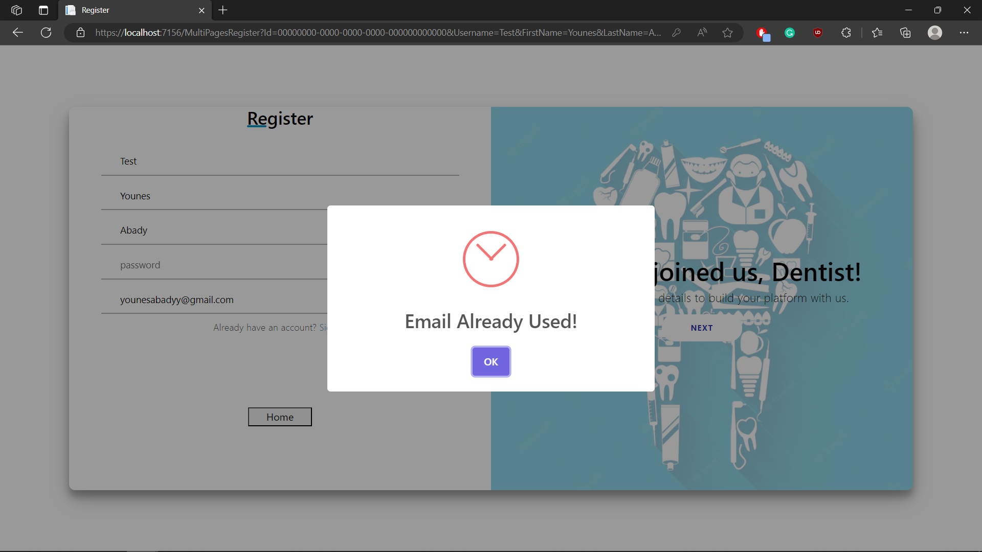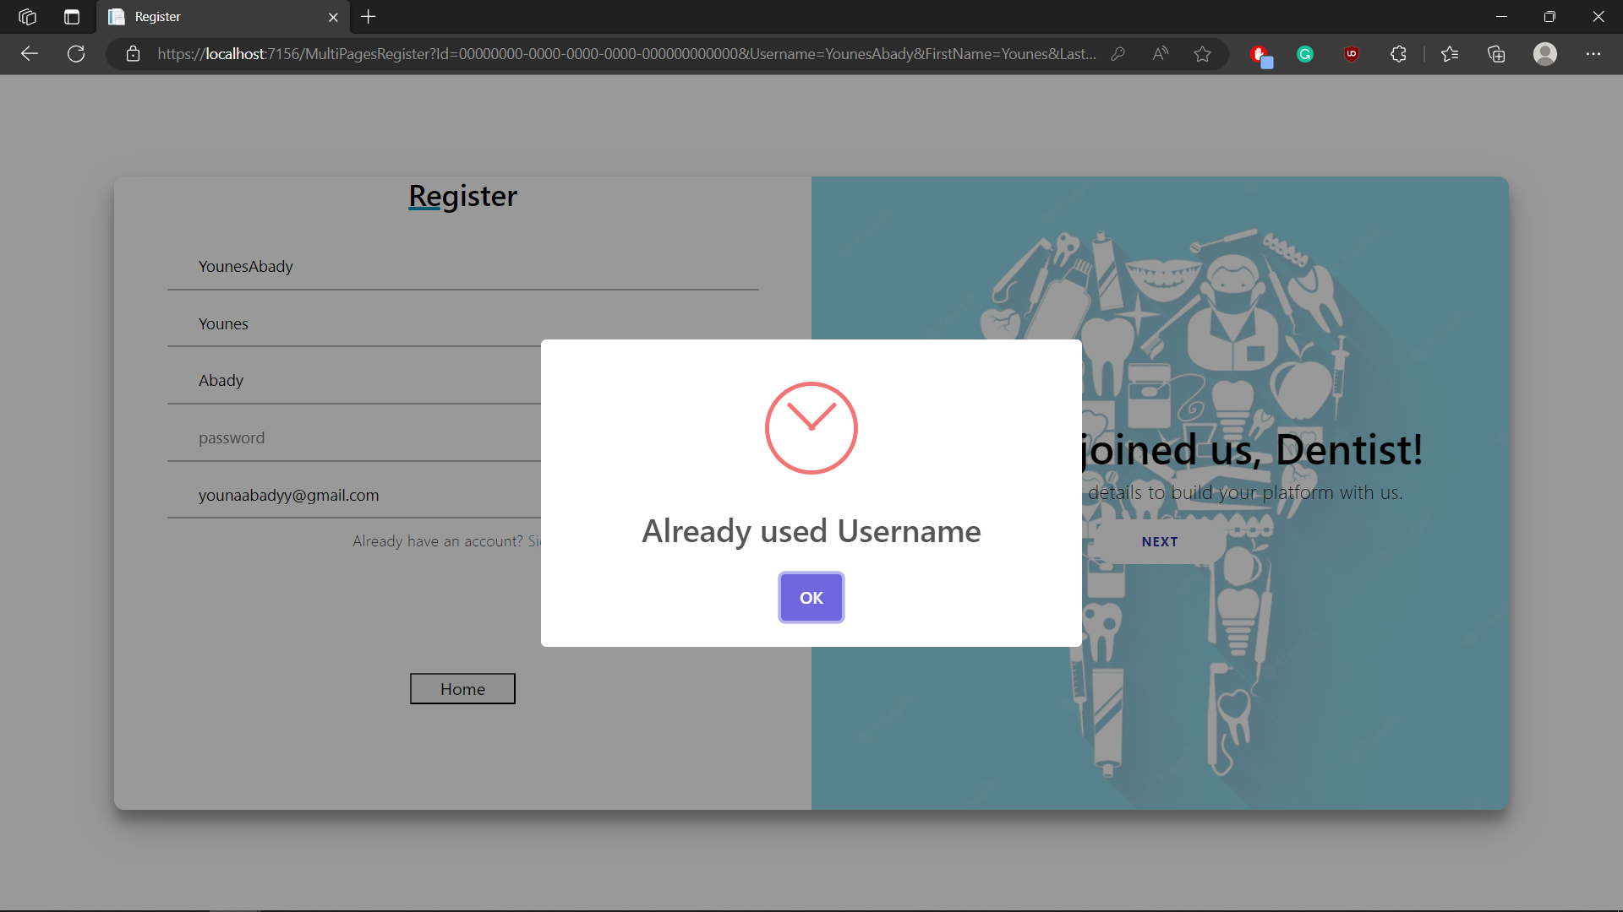

## Test case id : Register_Incomplete_Data

|  |  |  |  |
| --- | --- | --- | --- |
| Test Case | Test Steps | Test Data | Expected Result |
| Register with Incomplete data | 1. Go to registration page 2. Enter data 3. Press sign up | Not full data required | Prevents form to sign up and shows error messages under inputs required |

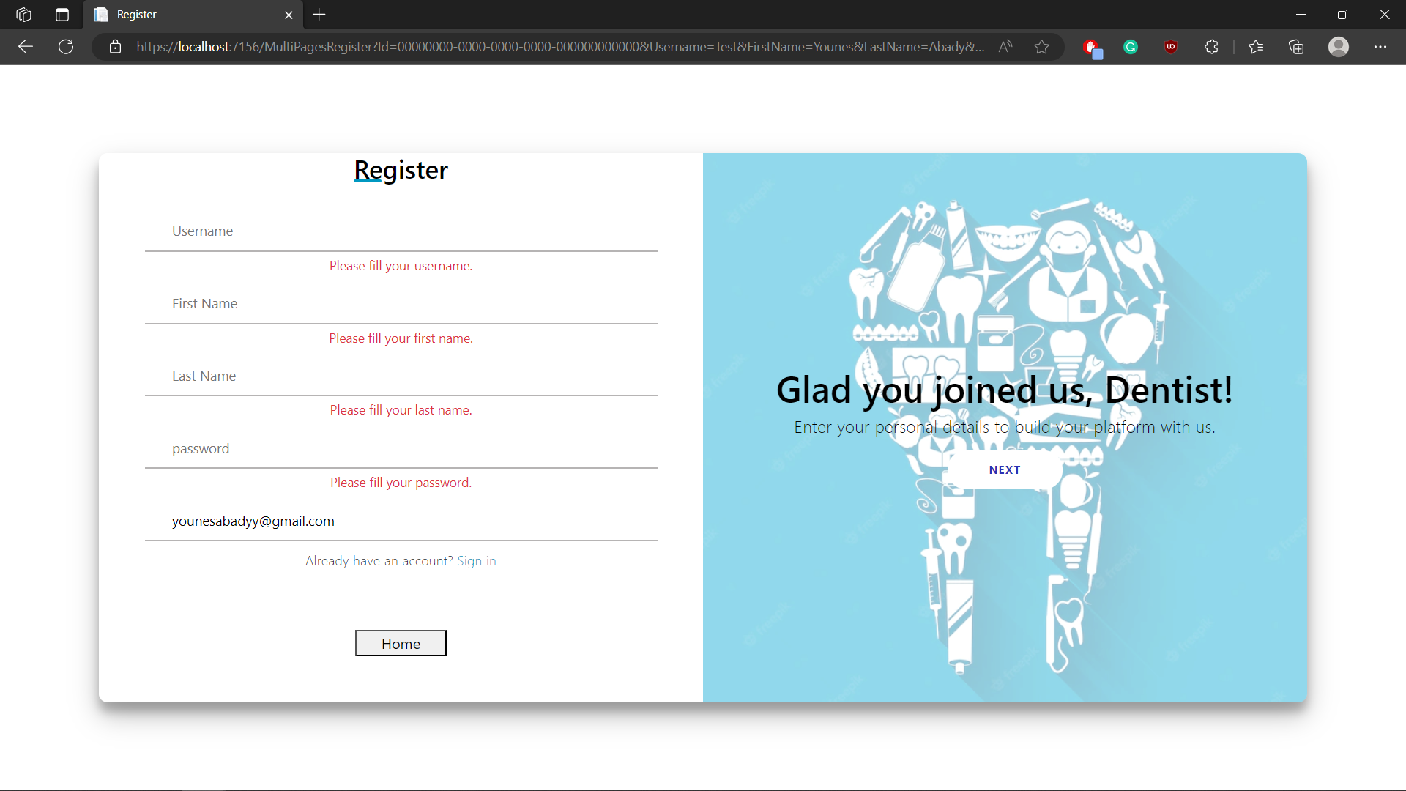

## Test case id : Register_Valid_Data

|  |  |  |  |
| --- | --- | --- | --- |
| Test Case | Test Steps | Test Data | Expected Result |
| Register with complete valid data | 1. Go to registration page 2. Enter data 3. Press sign up | Enter full and valid data | Redirects to home with a sign up successfully messge |

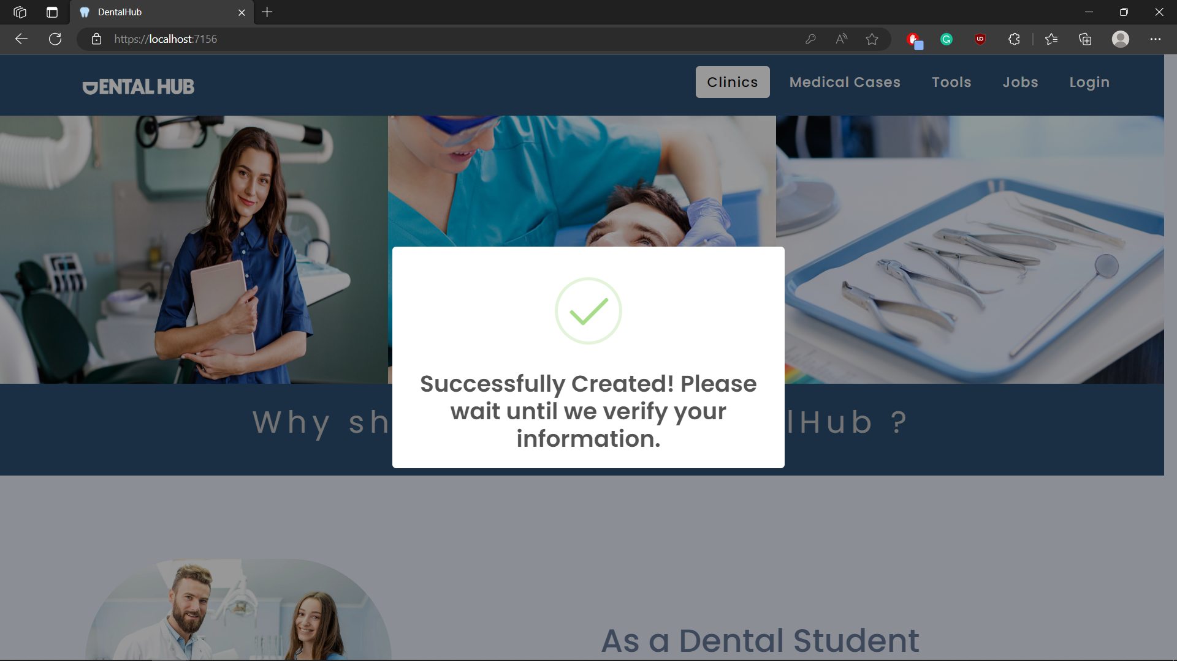

# Module Name : Login

## Test case id : Login_Incomplete_Data

|  |  |  |  |
| --- | --- | --- | --- |
| Test Case | Test Steps | Test Data | Expected Result |
| Login with Incomplete data | 1. Go to Login page 2. Enter data 3. Press Login | No data entered | Prevents Login |

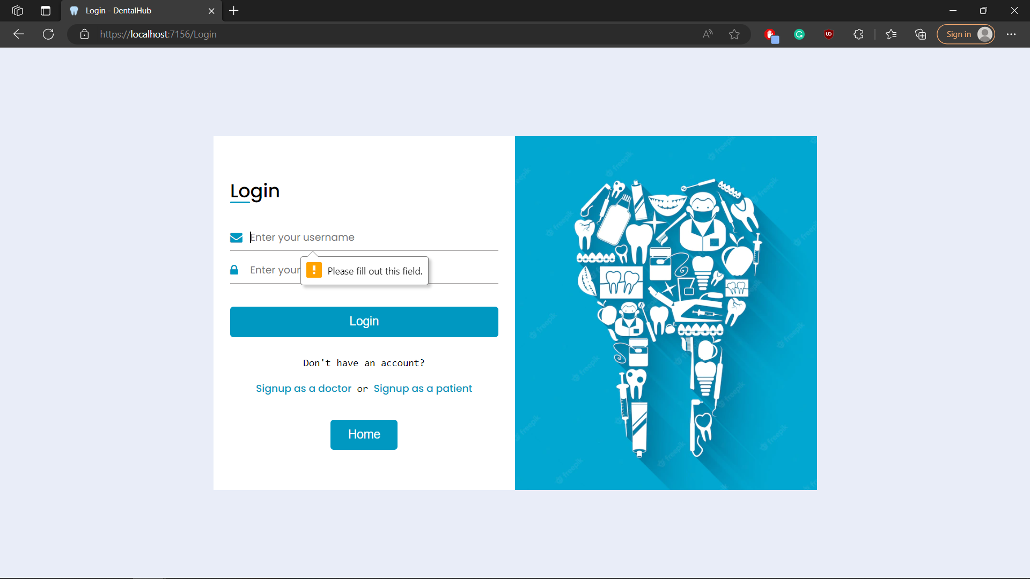

## Test case id : Login_Invalid_Data

|  |  |  |  |
| --- | --- | --- | --- |
| Test Case | Test Steps | Test Data | Expected Result |
| Login with Invalid data | 1. Go to Login page 2. Enter data 3. Press Login | Enter wrong username | Redirects to the same page with error message |

## 

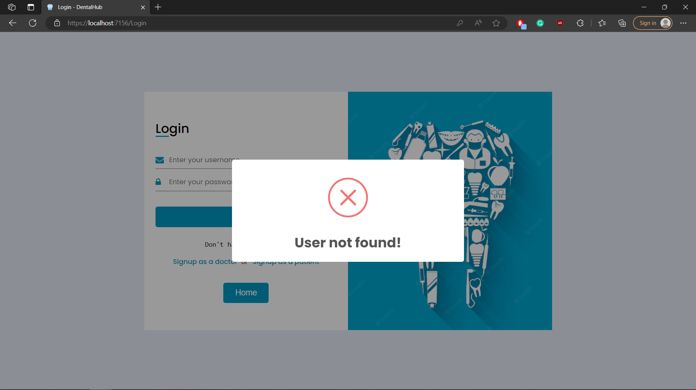

## Test case id : Login_Not_Verified_Yet

|  |  |  |  |
| --- | --- | --- | --- |
| Test Case | Test Steps | Test Data | Expected Result |
| Login with valid data but not verified user | 1. Go to Login page 2. Enter data 3. Press Login | Enter valid data but not verified user | Redirects to the verification page |

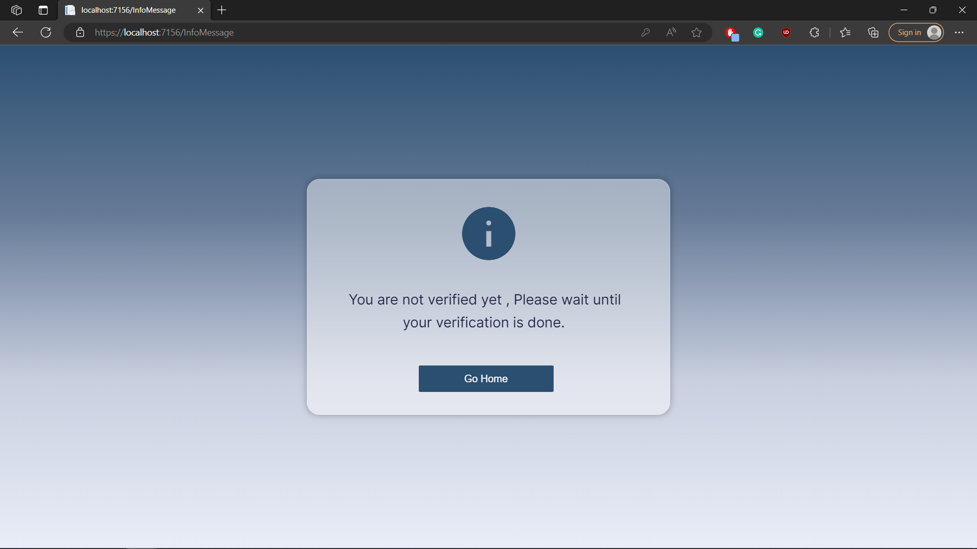

## Test case id : Login_ Verified

|  |  |  |  |
| --- | --- | --- | --- |
| Test Case | Test Steps | Test Data | Expected Result |
| Login with valid data and verified user | 1-Go to Login page  2-Enter data  3-Press Login | Enter valid data | Redirects to the home page with success message |

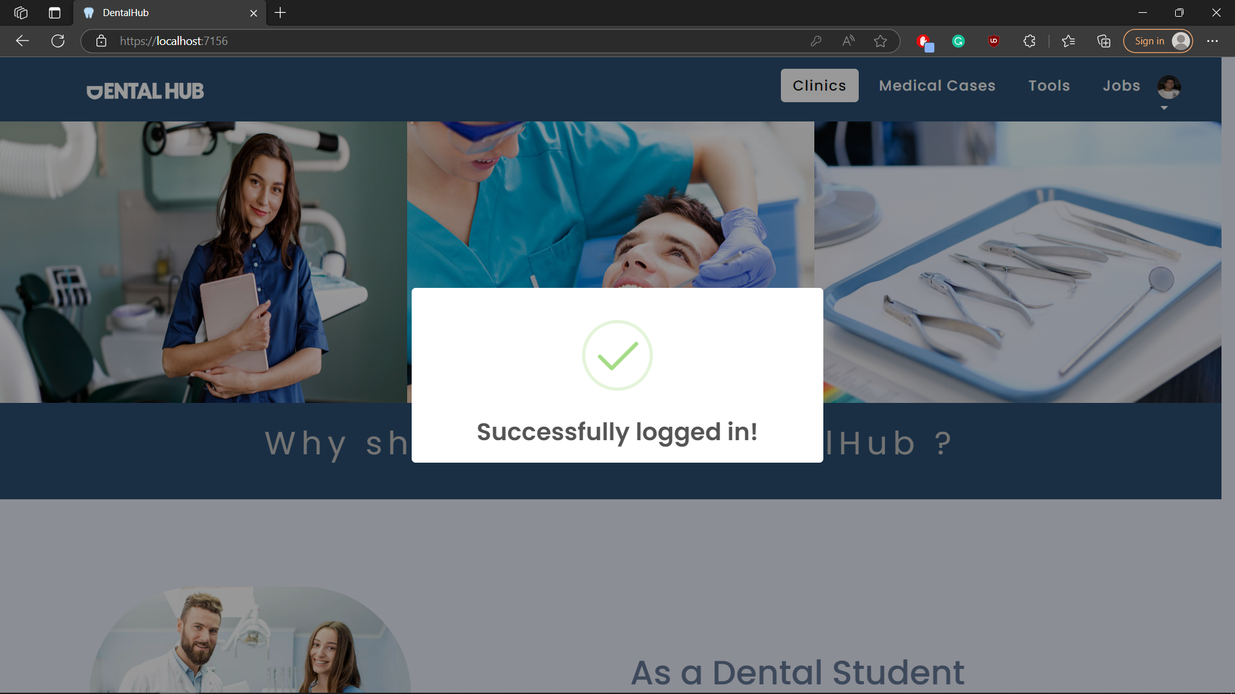

## Test case id : Login_ ReUpload_Data

|  |  |  |  |
| --- | --- | --- | --- |
| Test Case | Test Steps | Test Data | Expected Result |
| Login with valid data and user needs to change data to get verified | 1-Go to Login page  2-Enter data  3-Press Login | Enter valid data | Redirects to the edit profile page with error message with what he needs to change |

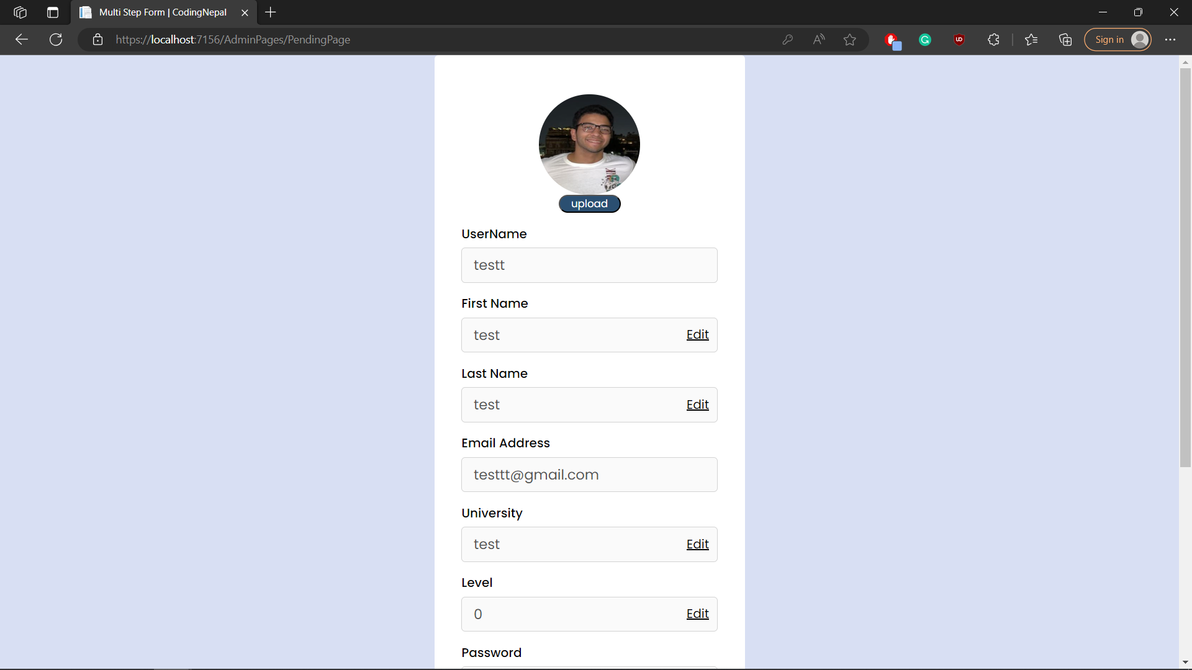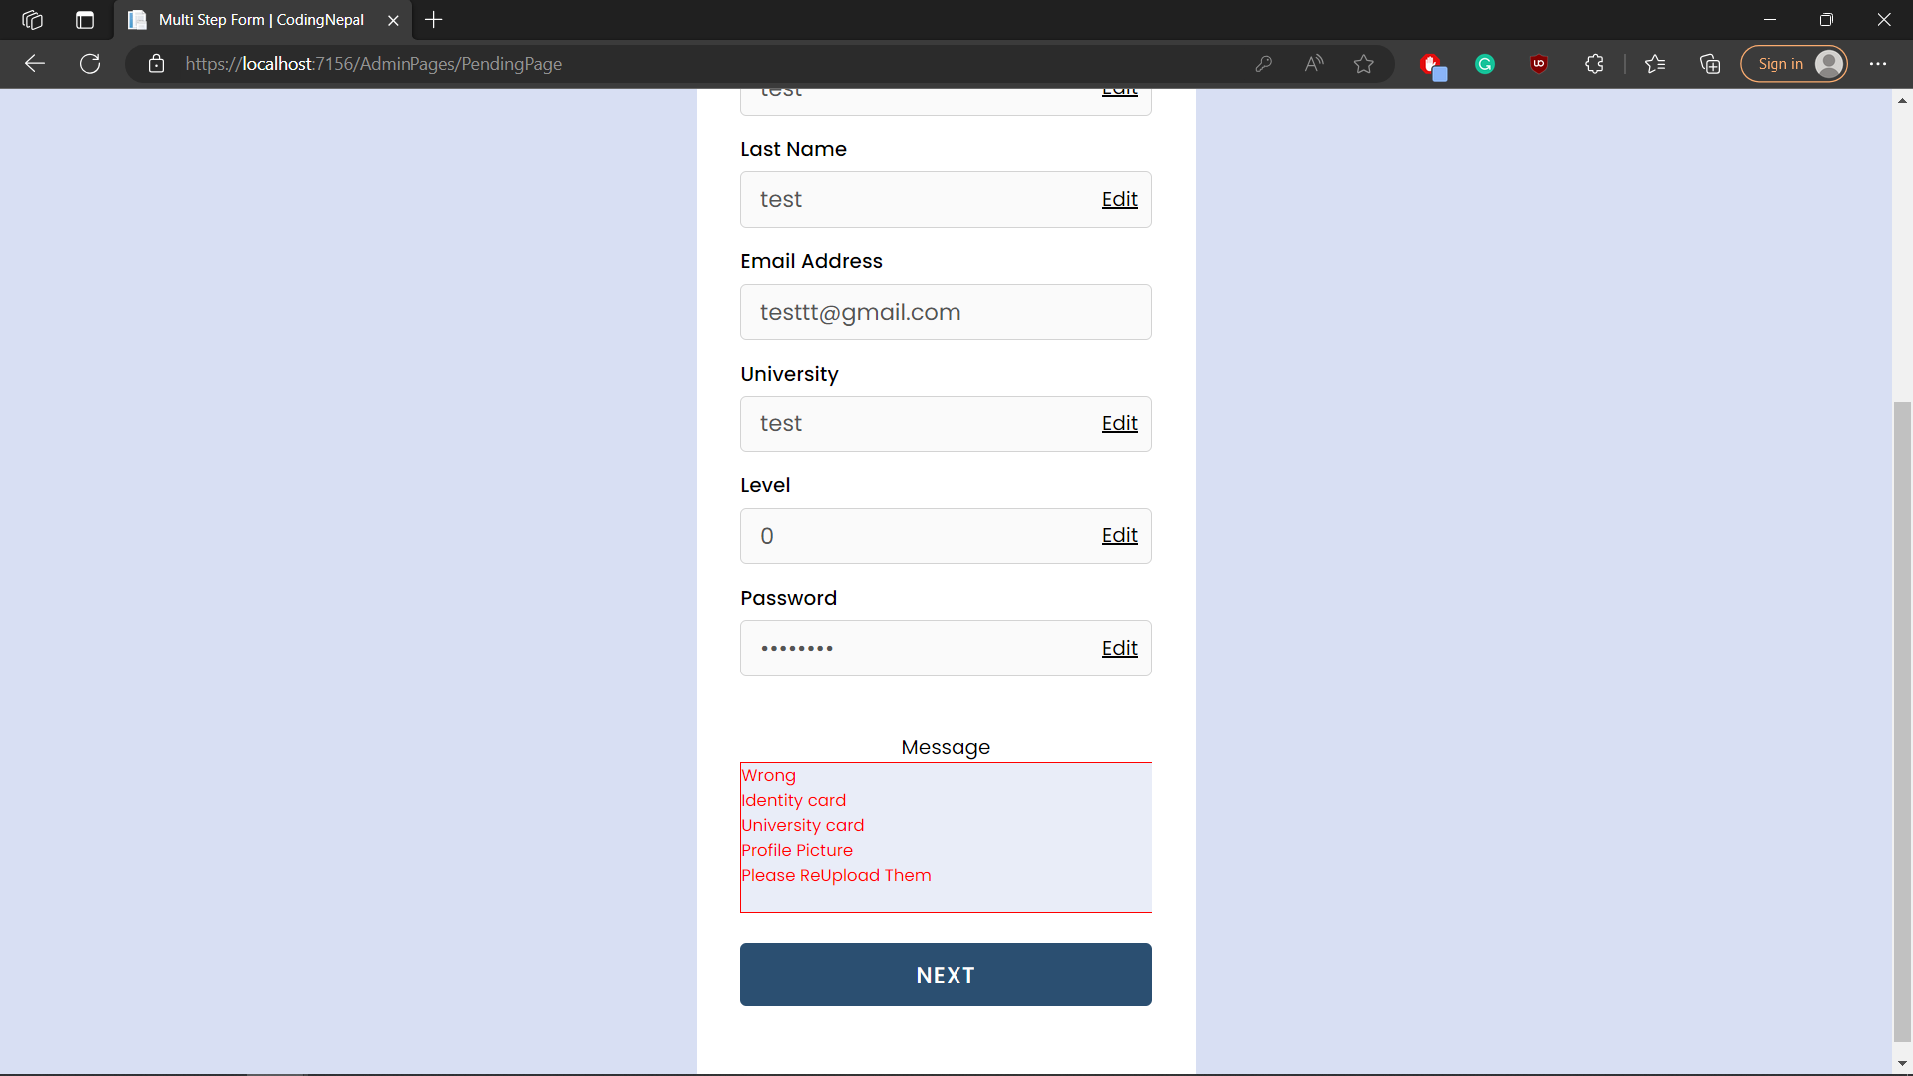

# Module Name : Admin

## Test case id : Admin_ Verify

|  |  |  |  |
| --- | --- | --- | --- |
| Test Case | Test Steps | Test Data | Expected Result |
| Admin checks data and everything is fine | 1-Go to Admin portal  2-check user data  3-Press Verify | Already Entered perfect user data | Redirects to the same page with success message  And send email to user with verified successfully message |

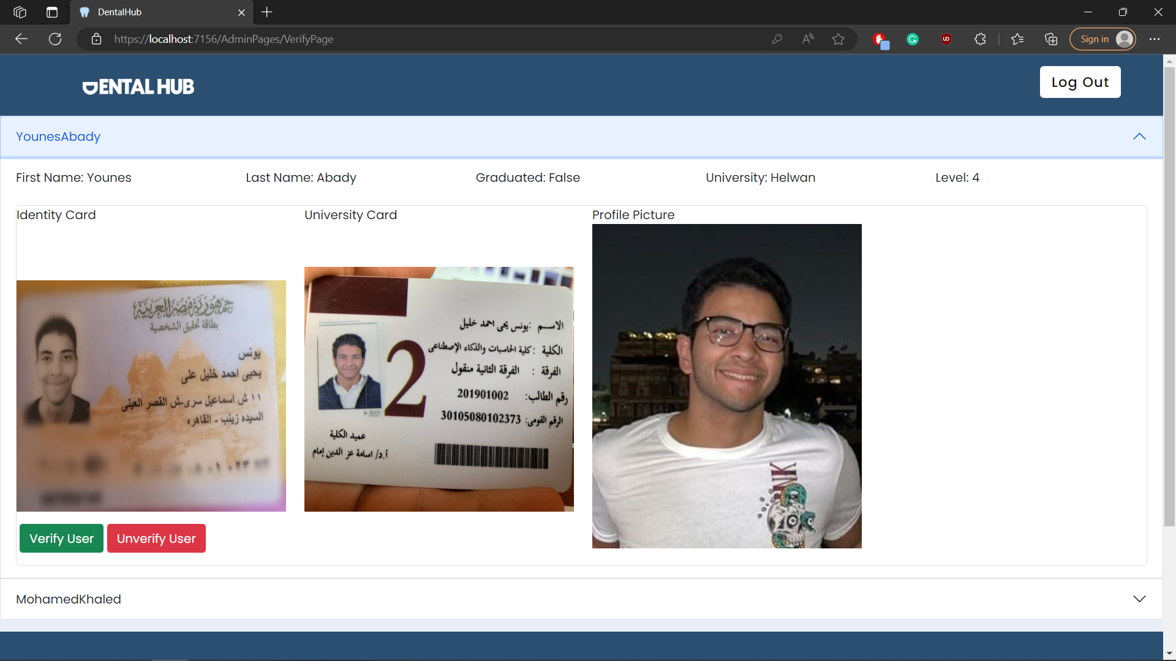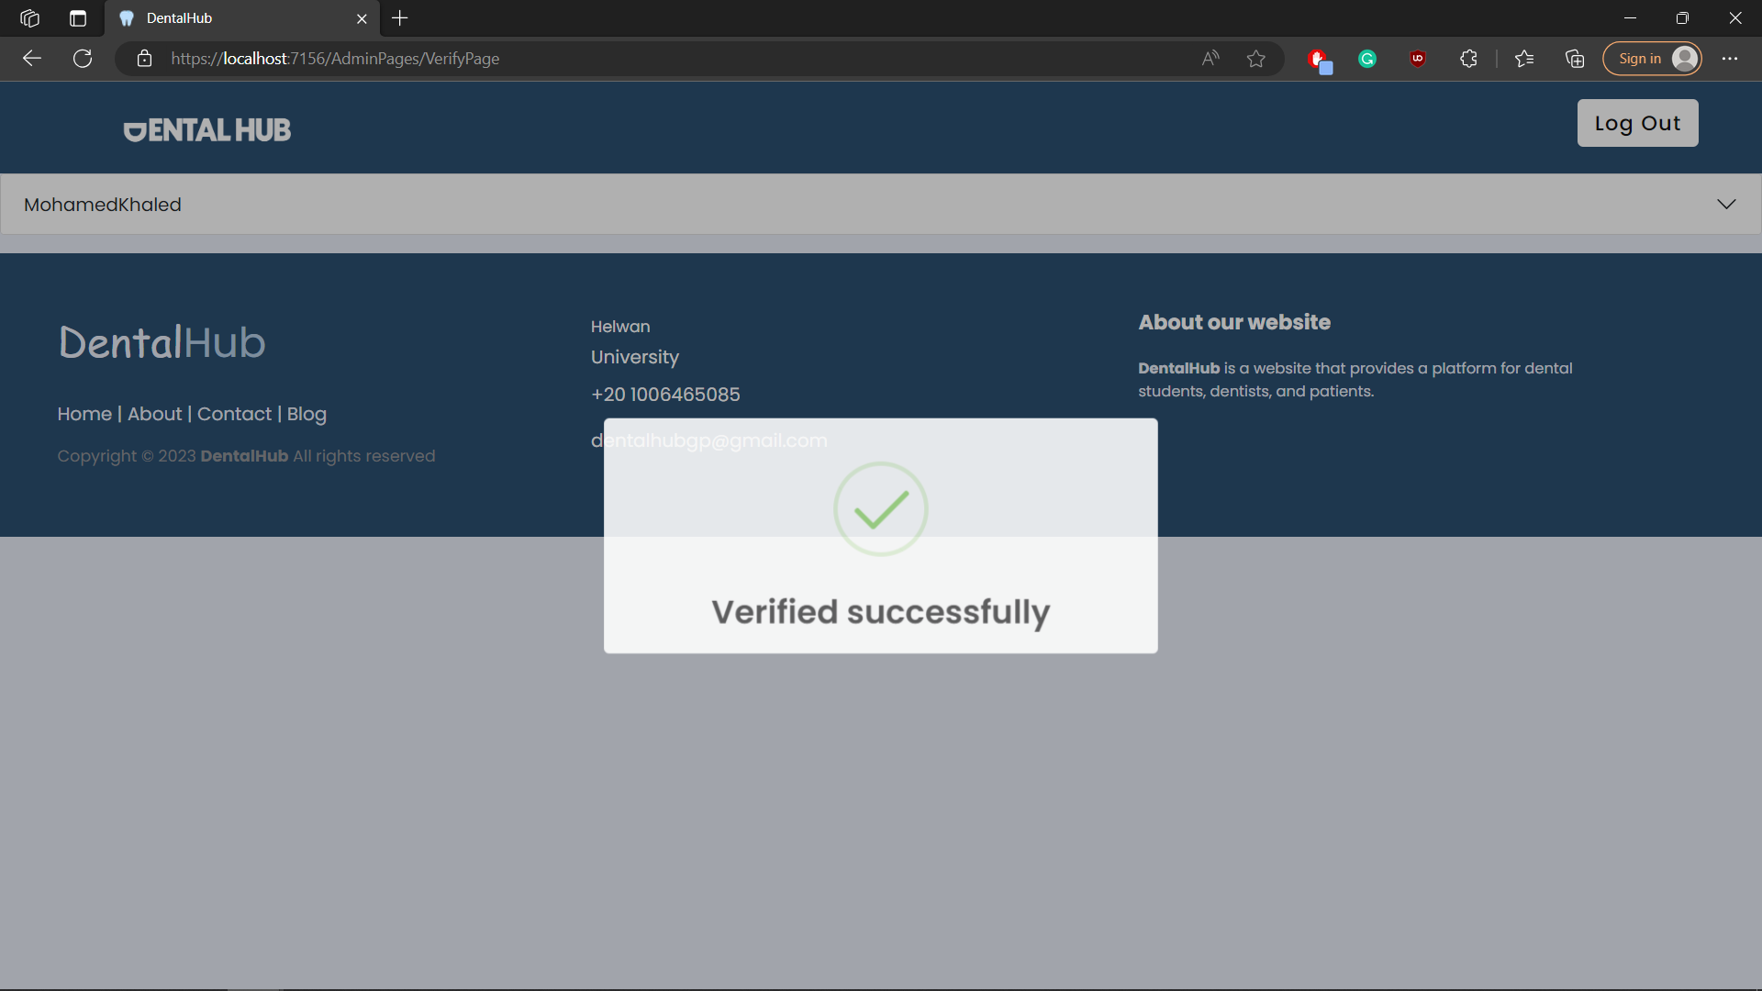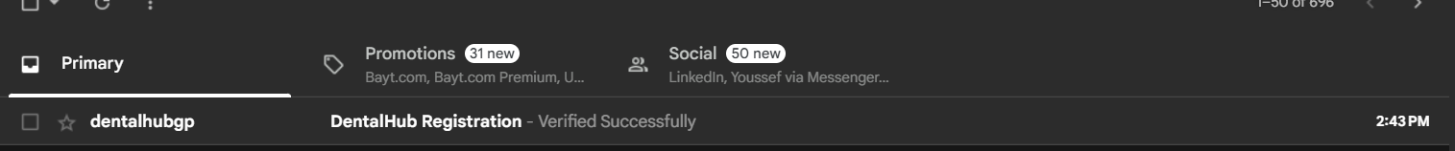

## Test case id : Admin_ Unverify

|  |  |  |  |
| --- | --- | --- | --- |
| Test Case | Test Steps | Test Data | Expected Result |
| Admin checks data and there are some data that needs to change | 1-Go to Admin portal  2-check user data  3-Press UnVerify | Already Entered invalid user data | Redirects to the same page with success message  And send email to user with Unverified message |

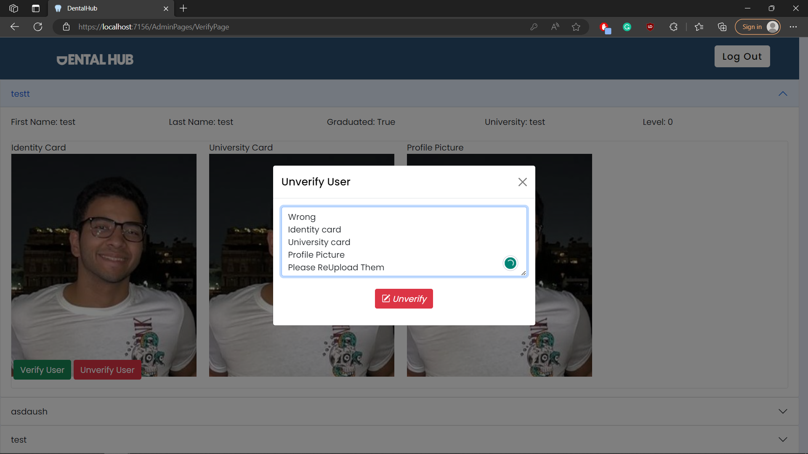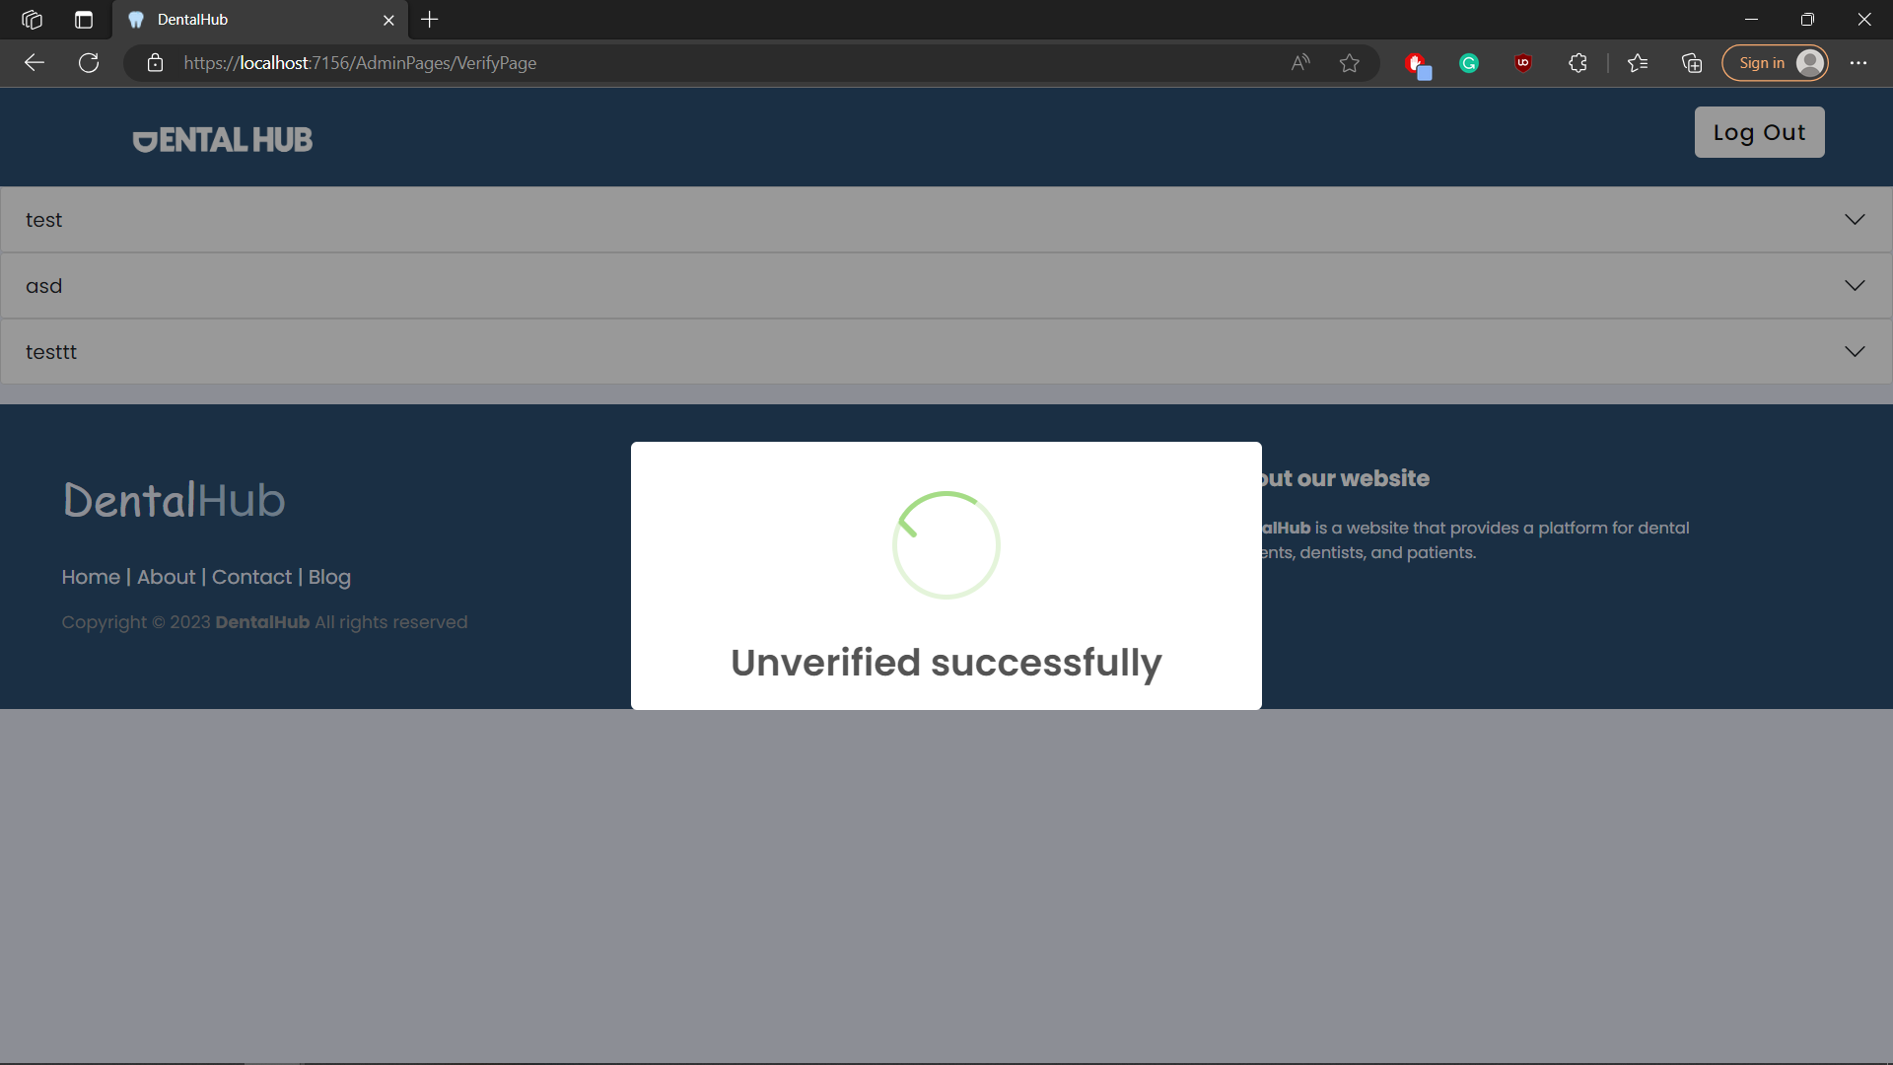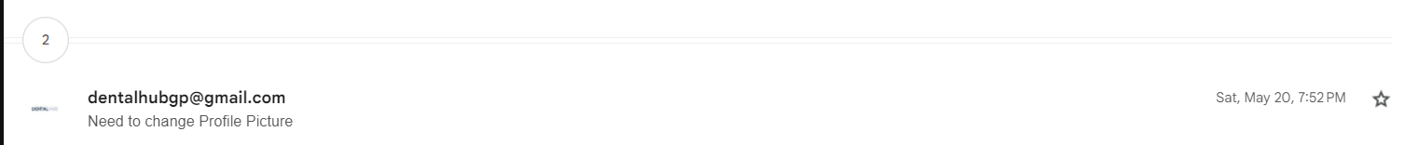

# Module Name : Clinic

## Test case id : Clinic_Display_Dentist

|  |  |  |  |
| --- | --- | --- | --- |
| Test Case | Test Steps | Test Data | Expected Result |
| Dentist Displays all clinics | 1-Go to Clinic Page |  | Displays all clinics  With edit & delete buttons if the user created this clinic |

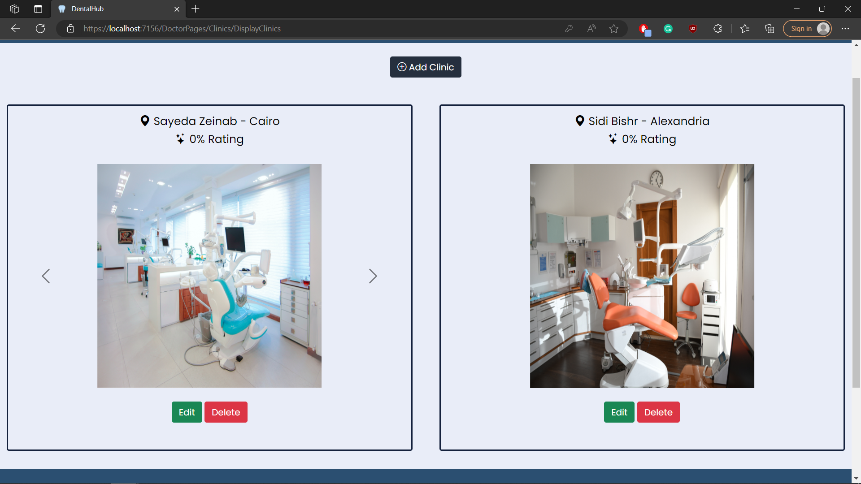

## Test case id : Clinic_Display_Patient

|  |  |  |  |
| --- | --- | --- | --- |
| Test Case | Test Steps | Test Data | Expected Result |
| Patient Displays all clinics | 1-Go to Clinic Page |  | Displays all clinics  With view buttons |

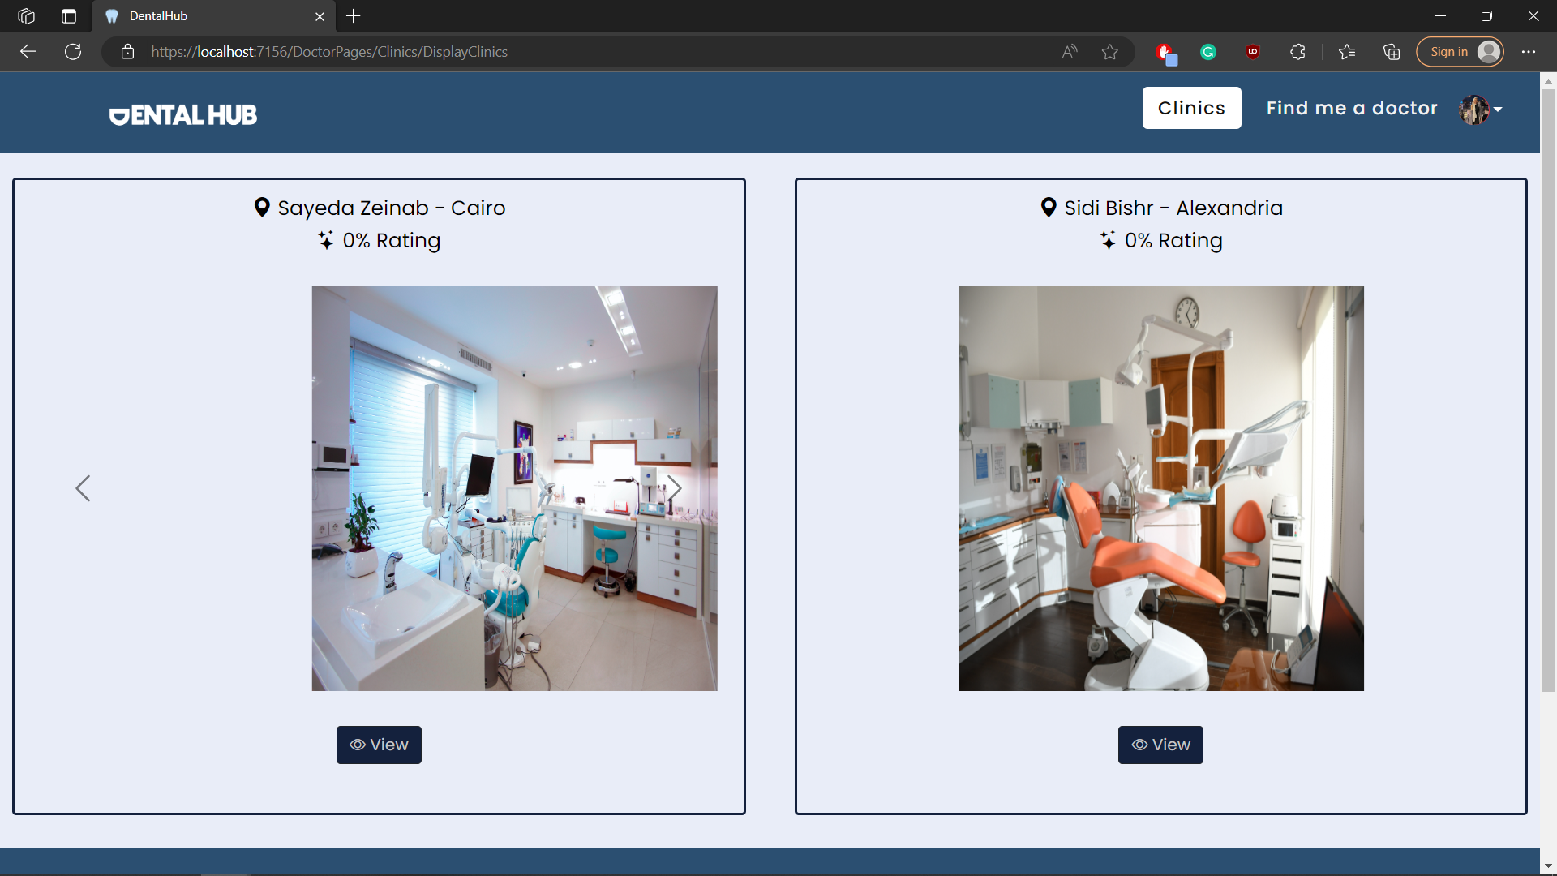

## Test case id : Clinic_View_Patient

|  |  |  |  |
| --- | --- | --- | --- |
| Test Case | Test Steps | Test Data | Expected Result |
| Patient View Clinic Information | 1-Go to Clinic Page  2- Press view |  | Redirects to view clinic page and displays all clinic data & feedbacks |

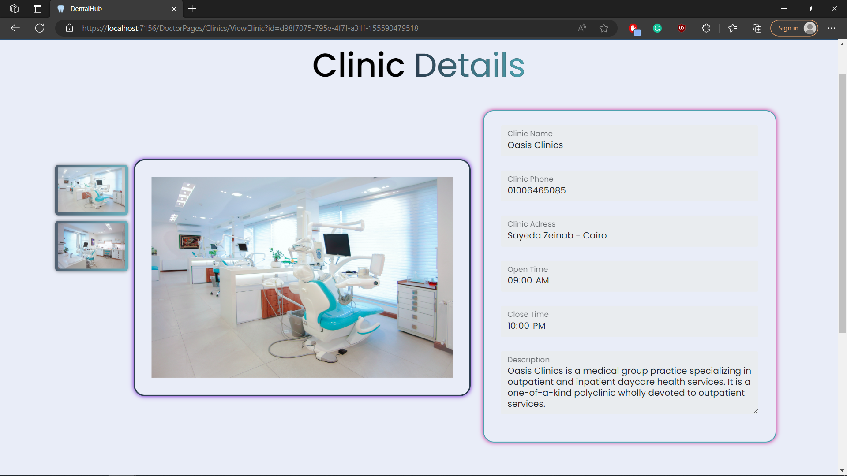

## Test case id : Clinic_Add_Incomplete_Data

|  |  |  |  |
| --- | --- | --- | --- |
| Test Case | Test Steps | Test Data | Expected Result |
| Dentist add clinic but with incomplete data | 1-Go to Clinic Page  2- Press add clinic  3-enter data | Incomplete required data | Prevents adding clinic and show error messages under required inputs |

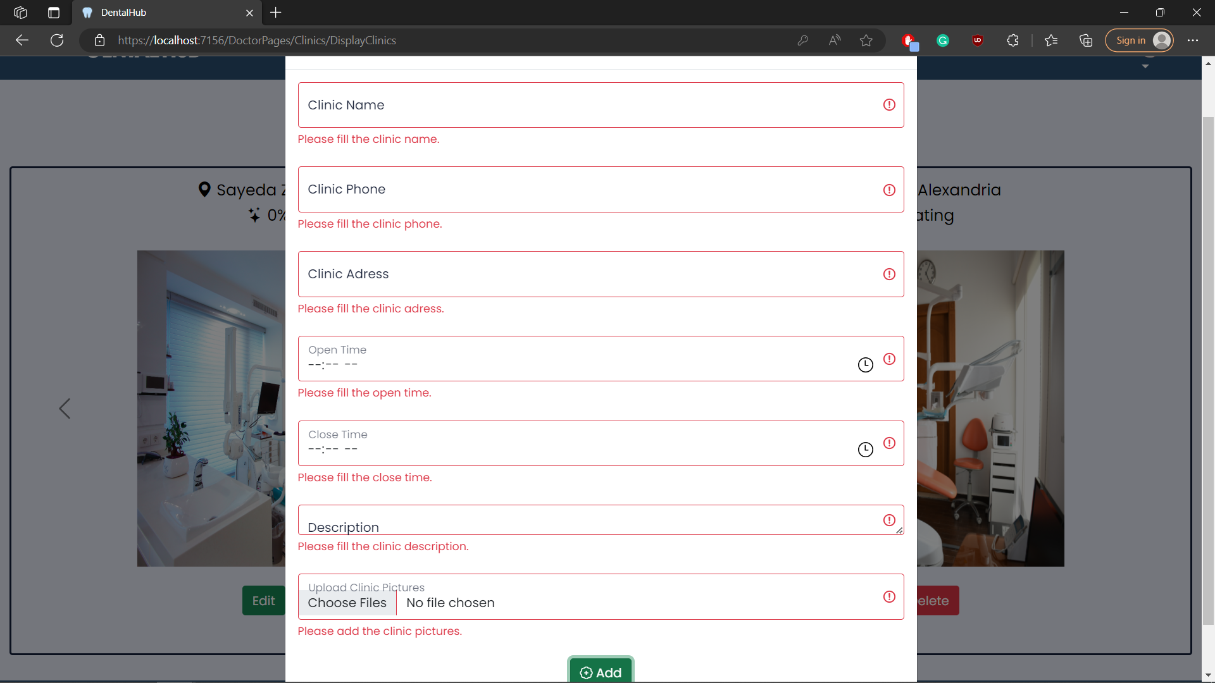

## Test case id : Clinic_Add_Invalid_Data

|  |  |  |  |
| --- | --- | --- | --- |
| Test Case | Test Steps | Test Data | Expected Result |
| Dentist add clinic but with invalid data | 1-Go to Clinic Page  2- Press add clinic  3-enter data | invalid data like clinic name already taken | Redirects to the same page with error message already taken |

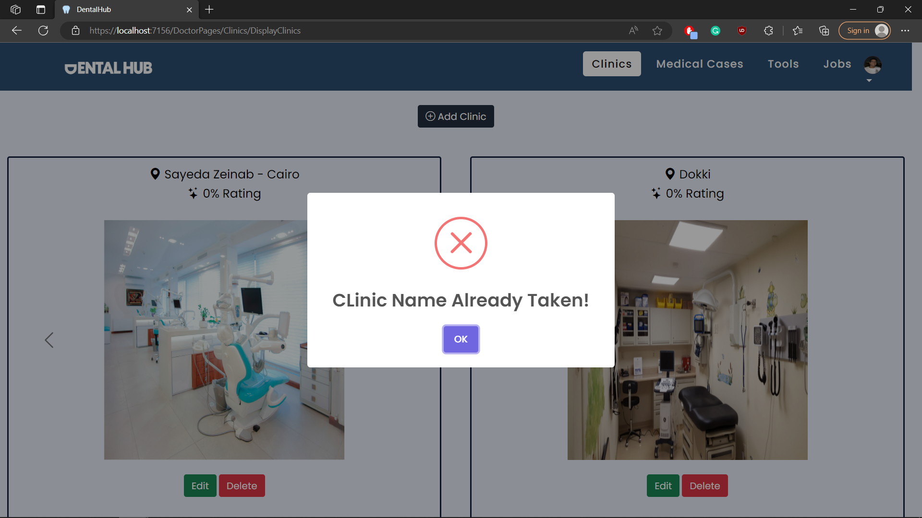

## Test case id : Clinic_Add_Valid_Data

|  |  |  |  |
| --- | --- | --- | --- |
| Test Case | Test Steps | Test Data | Expected Result |
| Dentist add clinic with valid data | 1-Go to Clinic Page  2- Press add clinic  3-enter data | Complete and valid required data | Adds successfuly |

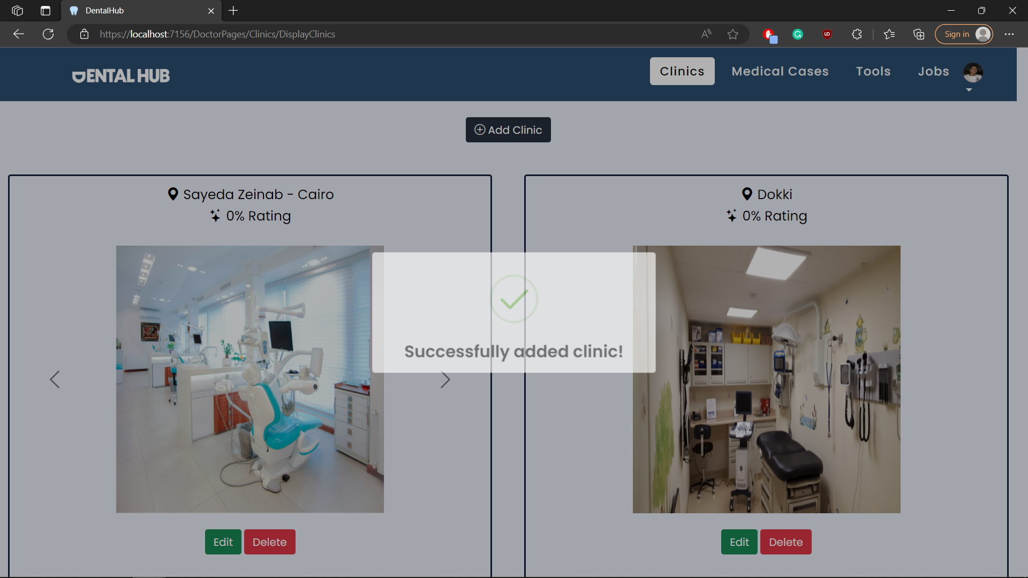

## Test case id : Clinic_Delete

|  |  |  |  |
| --- | --- | --- | --- |
| Test Case | Test Steps | Test Data | Expected Result |
| Dentist deletes a clinic | 1-Go to Clinic Page  2- Press delete  3-press yes delete it |  | Deletes successfully |

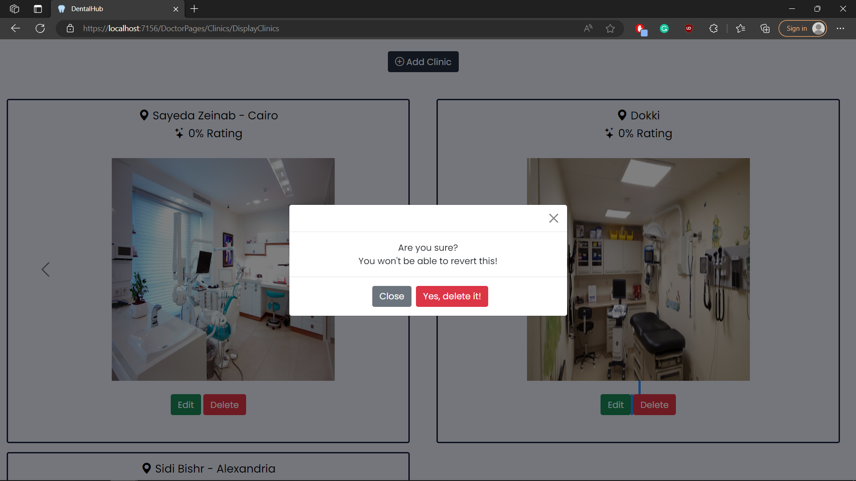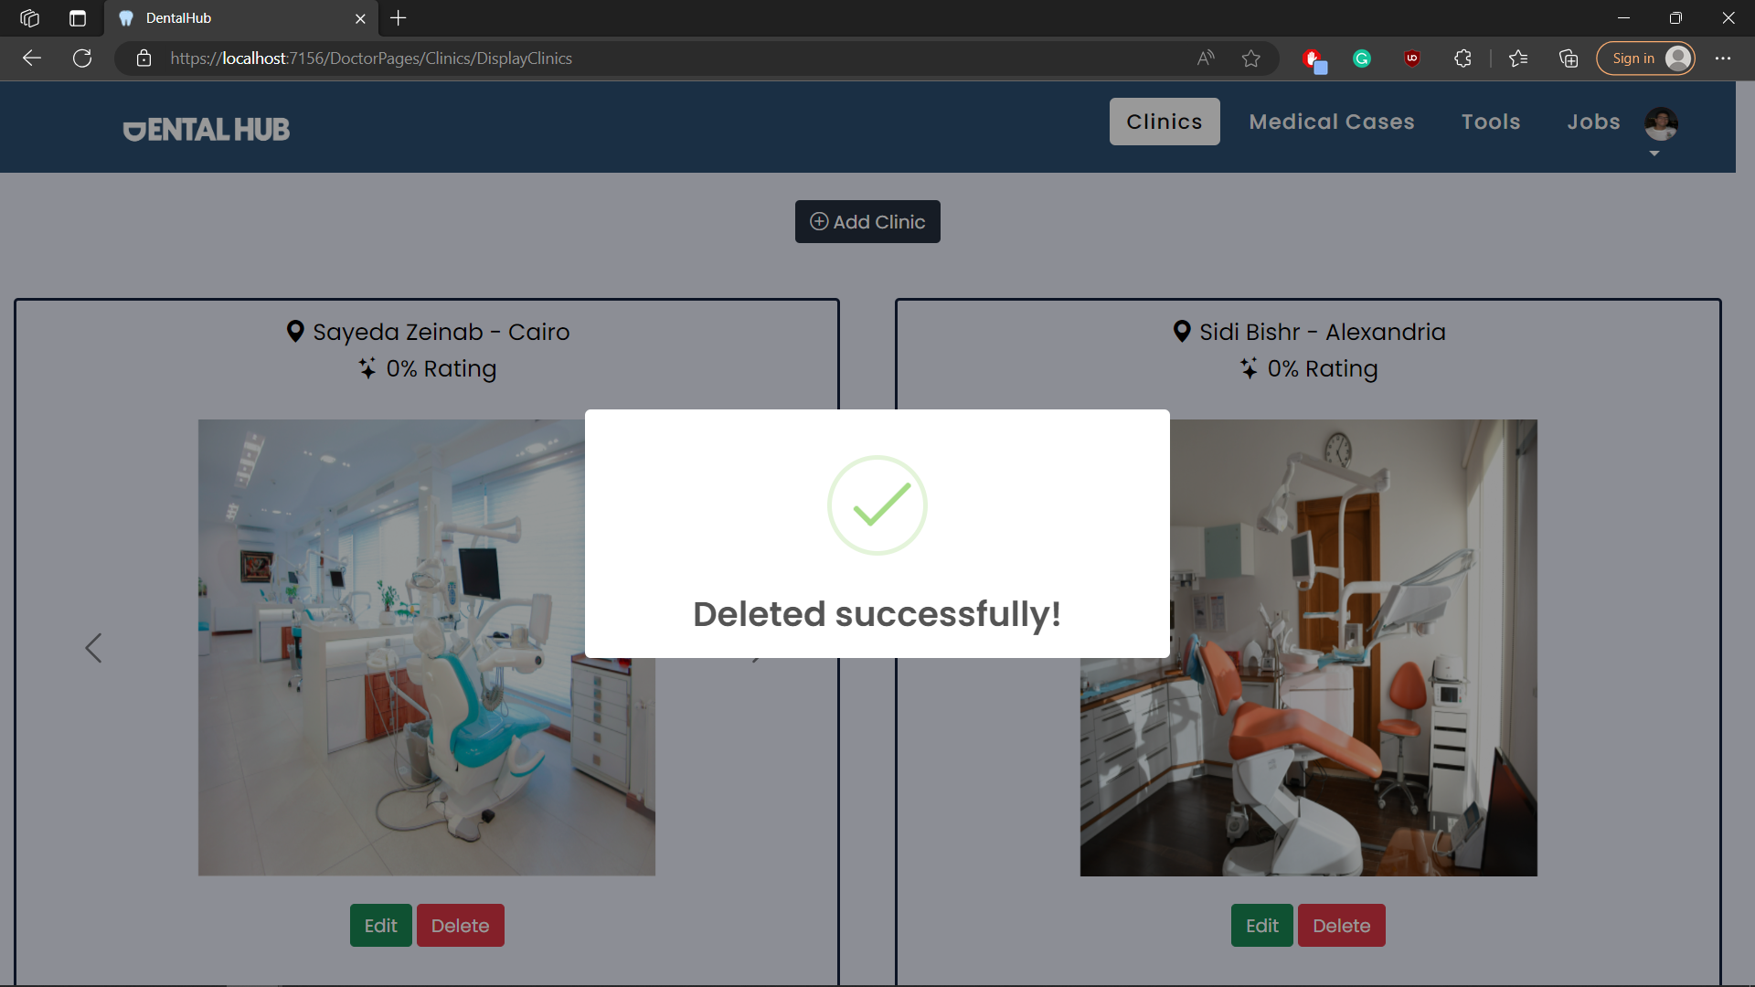

## Test case id : Clinic_Edit

|  |  |  |  |
| --- | --- | --- | --- |
| Test Case | Test Steps | Test Data | Expected Result |
| Dentist edits a clinic | 1-Go to Clinic Page  2- Press edit  3-enter data | Edit with no missing or wrong data | Edited successfully |

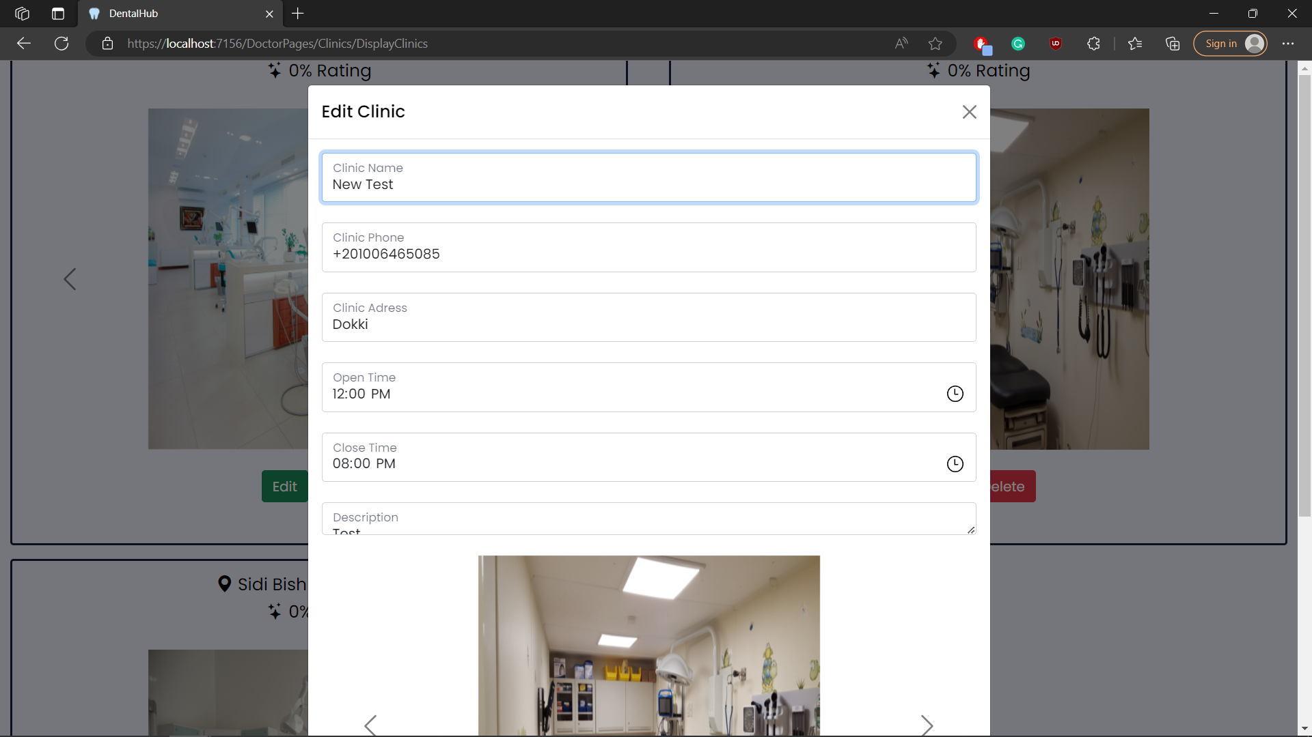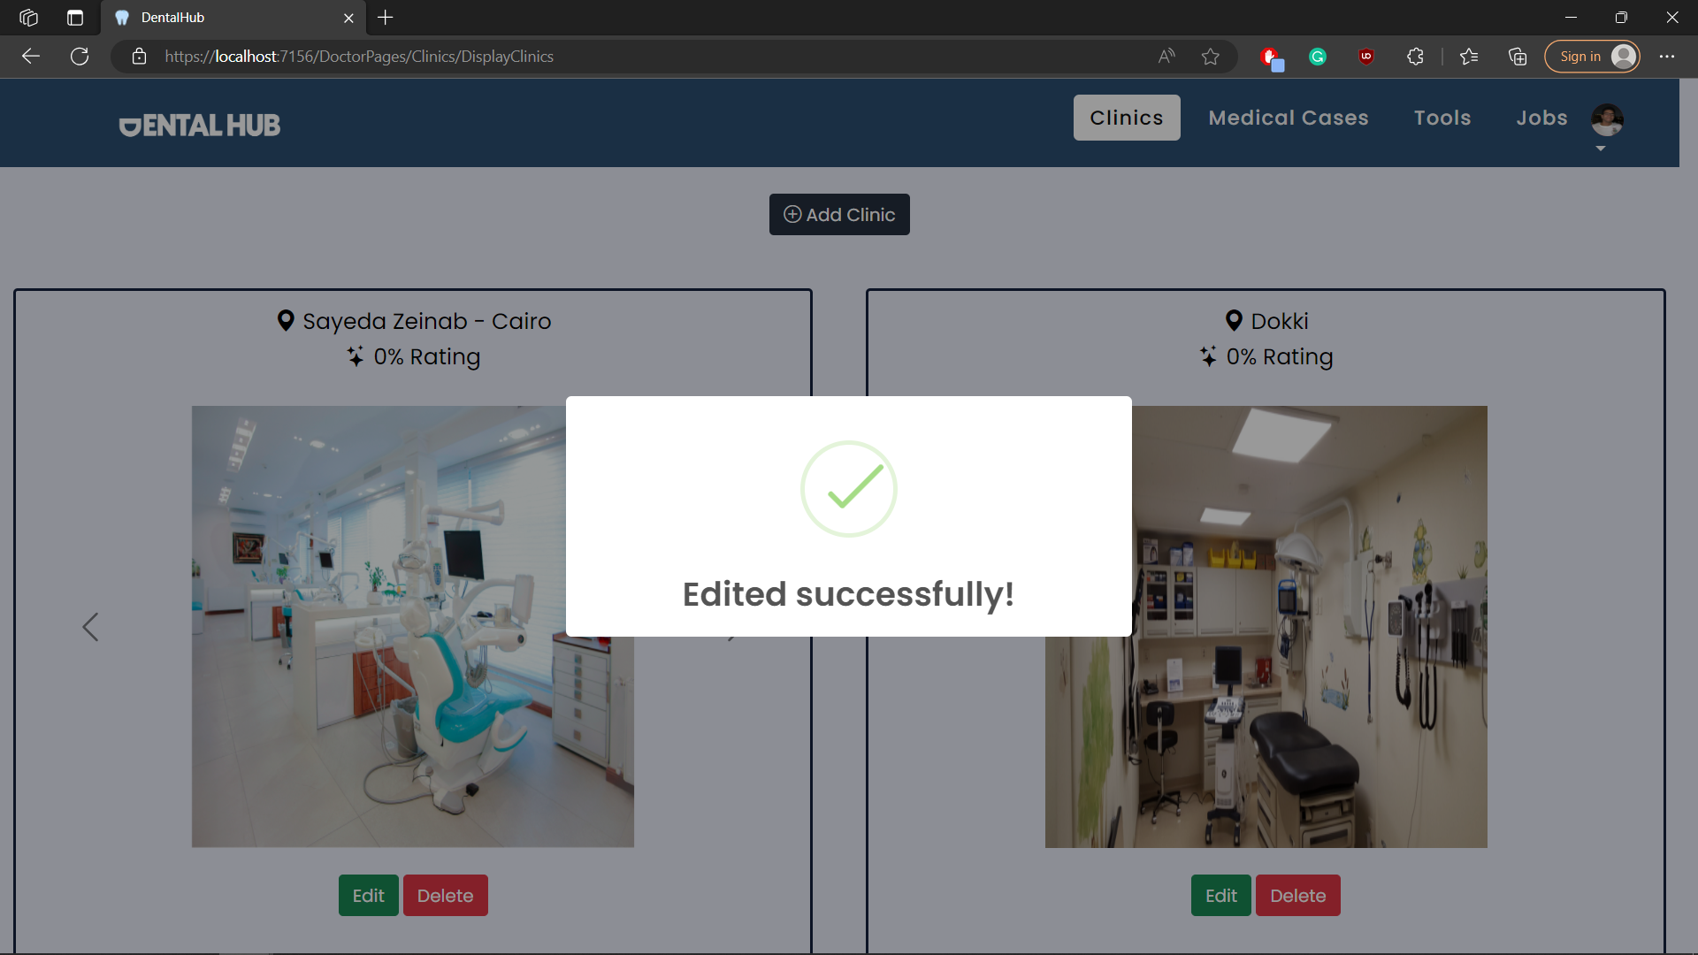

# Module Name : Clinic_Feedback

## Test case id : Clinic_Feedback_Good

|  |  |  |  |
| --- | --- | --- | --- |
| Test Case | Test Steps | Test Data | Expected Result |
| Patient Adds a good feedback | 1-Go to Clinic Page  2- Press view  3-enter feed back | Add a feedback | Feedback added successfully with a happy face if its positive and change clinic rating |

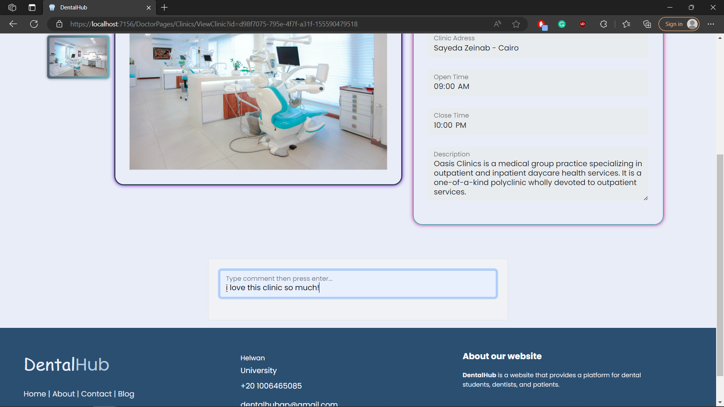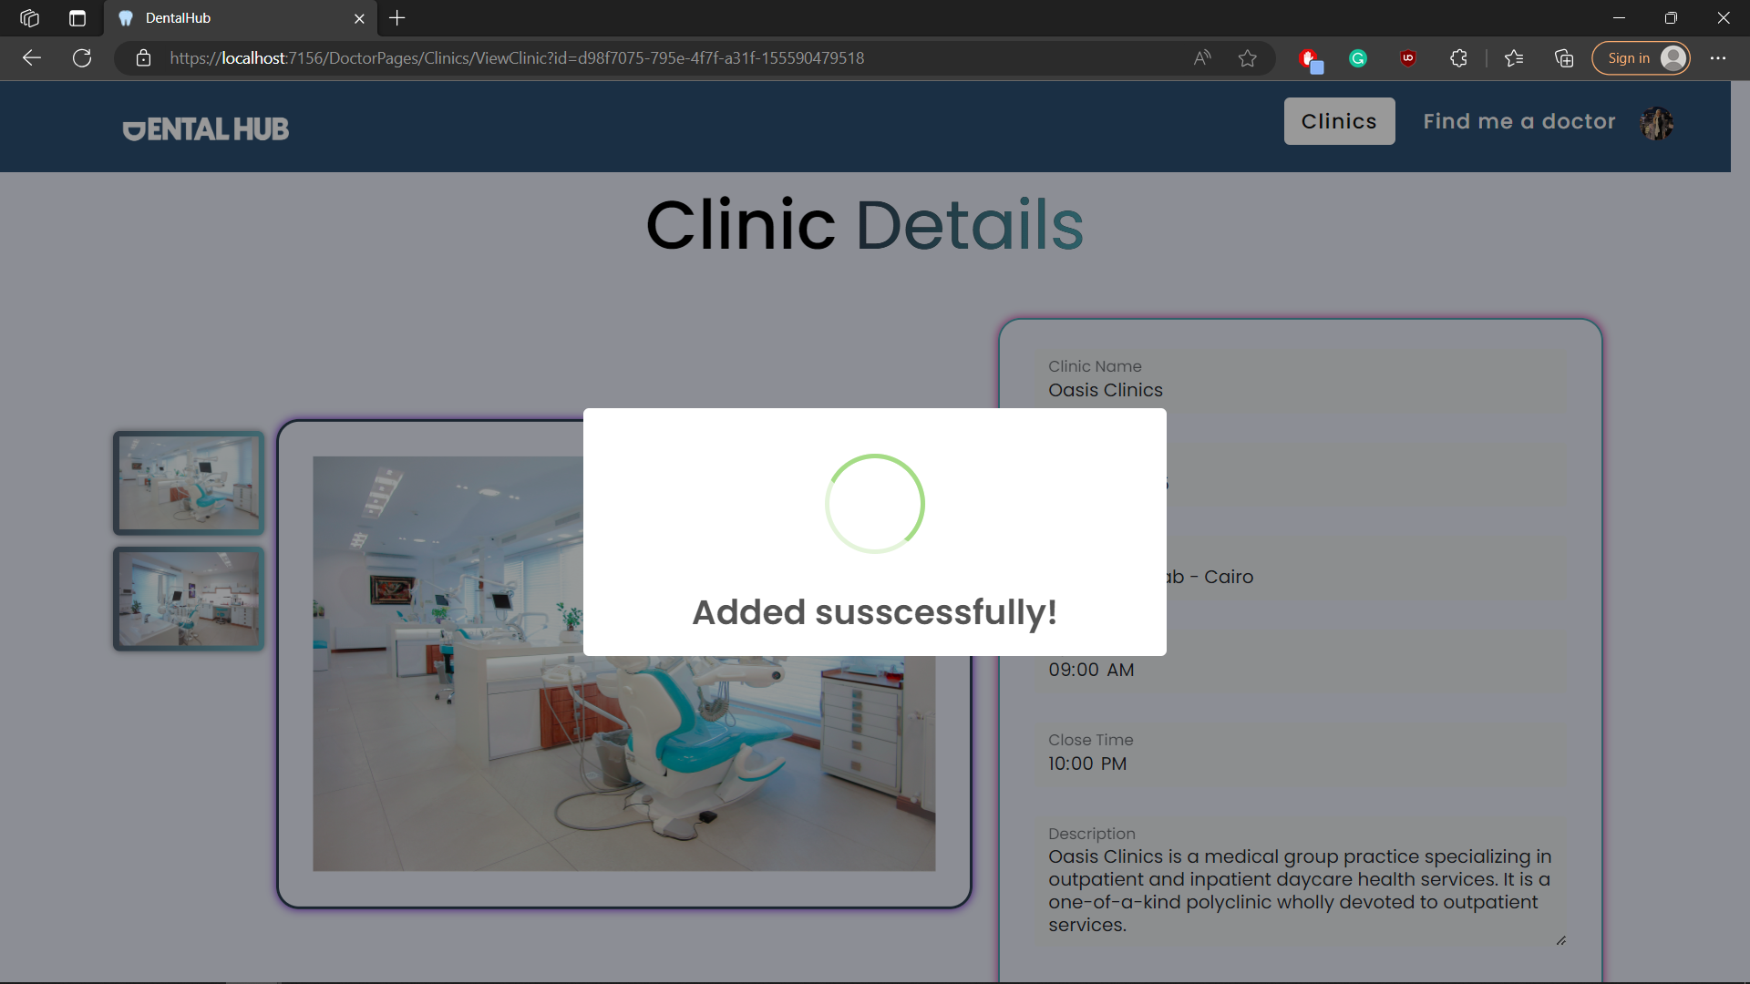

## Test case id : Clinic_Feedback_Bad

|  |  |  |  |
| --- | --- | --- | --- |
| Test Case | Test Steps | Test Data | Expected Result |
| Patient Adds a bad feedback | 1-Go to Clinic Page  2- Press view  3-enter feed back | Add a feedback | Feedback added successfully with a sad face if its negative and change clinic rating |

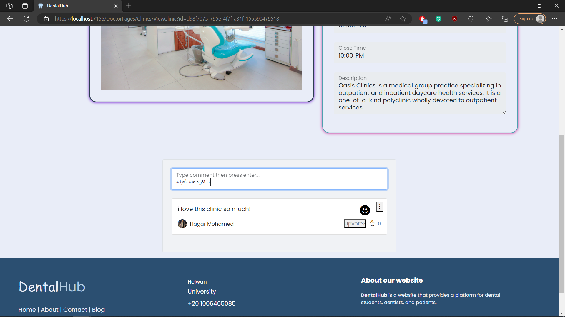

## Test case id : Clinic_Feedback_Display

|  |  |  |  |
| --- | --- | --- | --- |
| Test Case | Test Steps | Test Data | Expected Result |
| Patient Display clinic feedbacks | 1-Go to Clinic Page  2- Press view |  | Patient sees all feedbacks with its ratings as happy – sad faces |

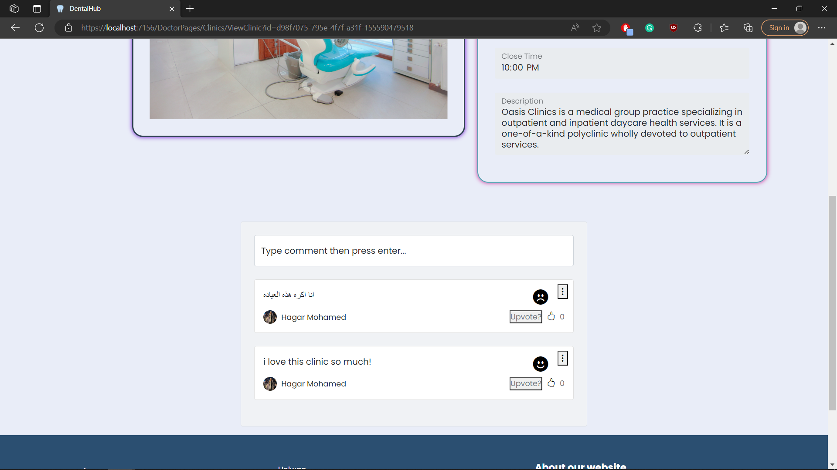

## Test case id : Clinic_Feedback_Rating

|  |  |  |  |
| --- | --- | --- | --- |
| Test Case | Test Steps | Test Data | Expected Result |
| Patient checks clinic rating | 1-Go to Clinic Page |  | Patient sees all clinics with ratings |

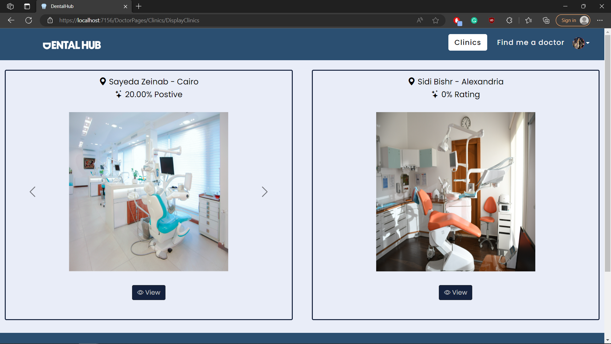

## Test case id : Clinic_Feedback_Upvote

|  |  |  |  |
| --- | --- | --- | --- |
| Test Case | Test Steps | Test Data | Expected Result |
| Patient upvote a feed back he agrees with | 1-Go to Clinic Page  2- Press view  3-press upvote |  | Feedback is upvoted and feedbacks with the most upvotes shows first |

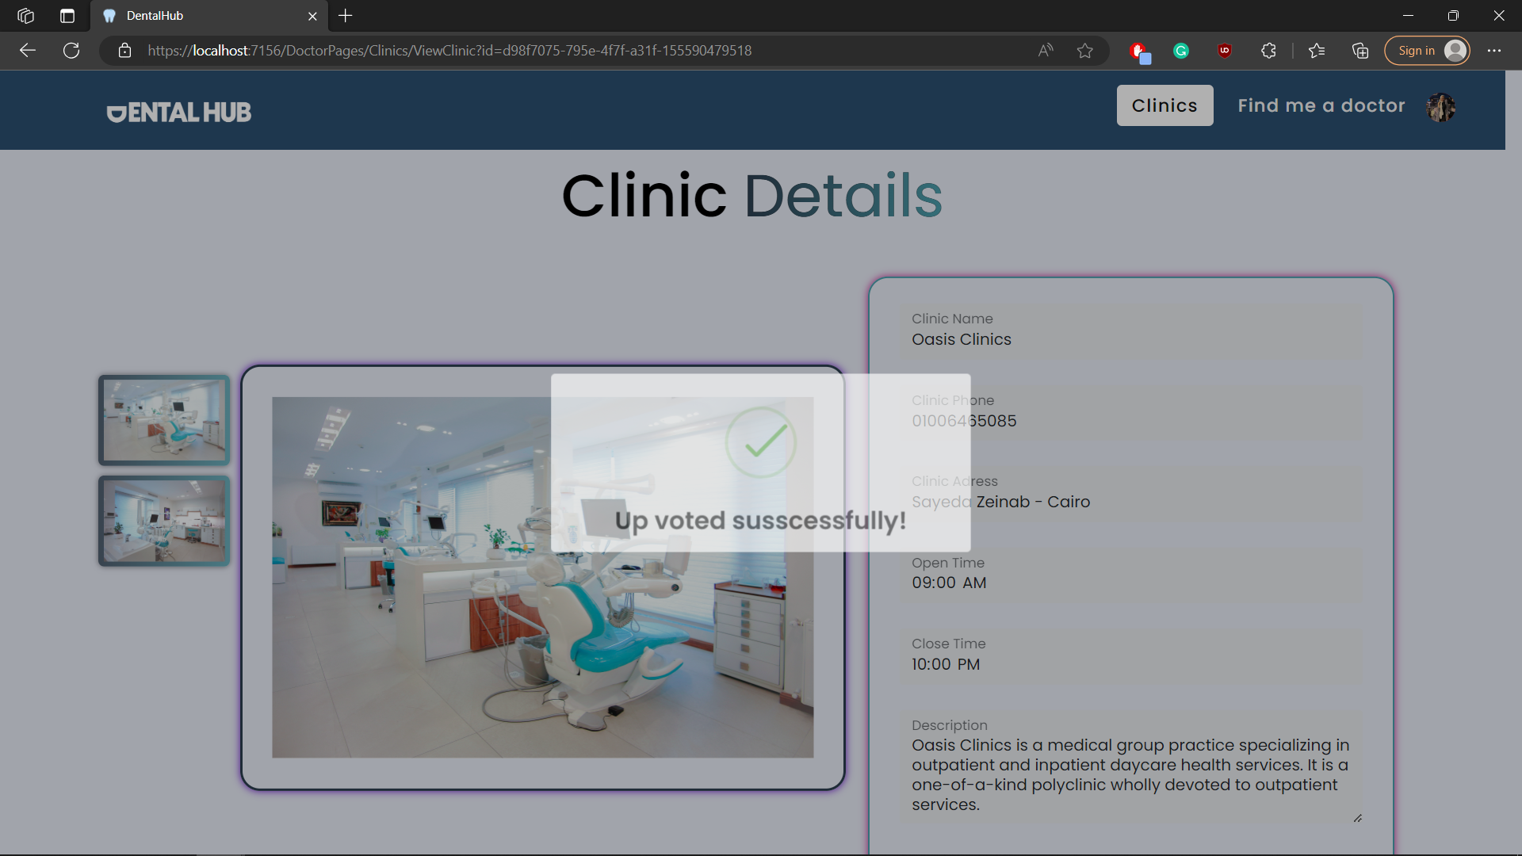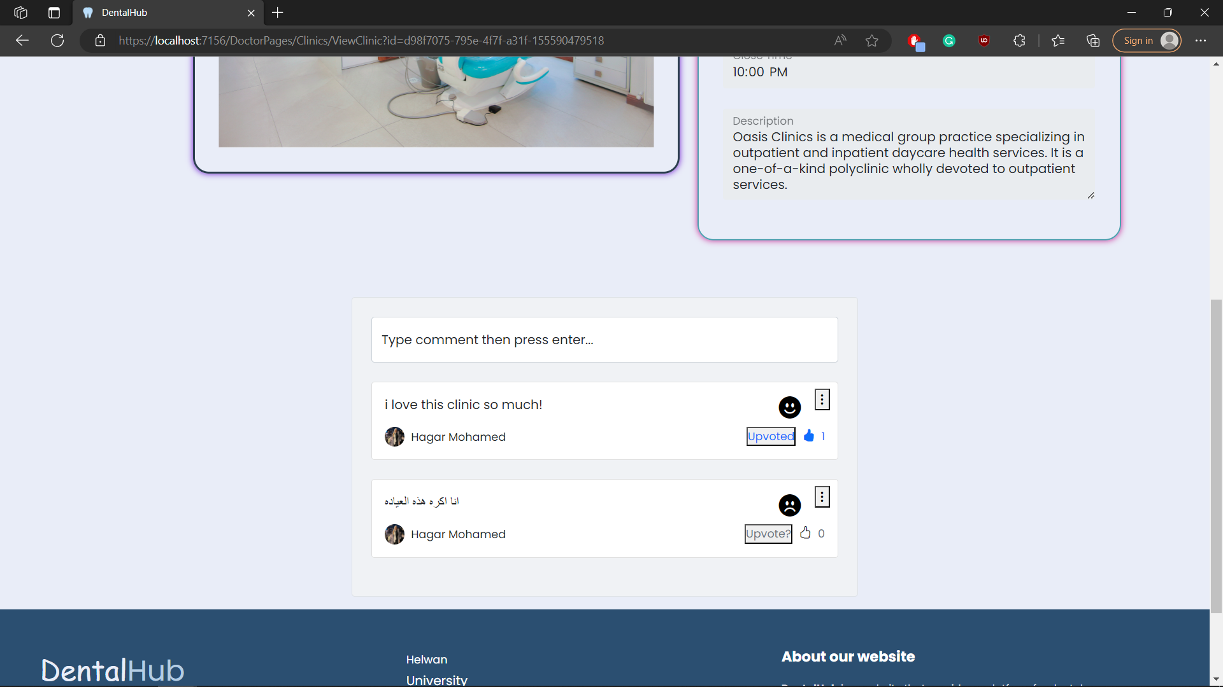

## Test case id : Clinic_Feedback_Edit

|  |  |  |  |
| --- | --- | --- | --- |
| Test Case | Test Steps | Test Data | Expected Result |
| Patient edits his own feedback | 1-Go to Clinic Page  2- Press view  3-press the 3 dots then edit | Enter new feedback | Feedback edited successfully with a new AI rating and changes clinic overall rating |

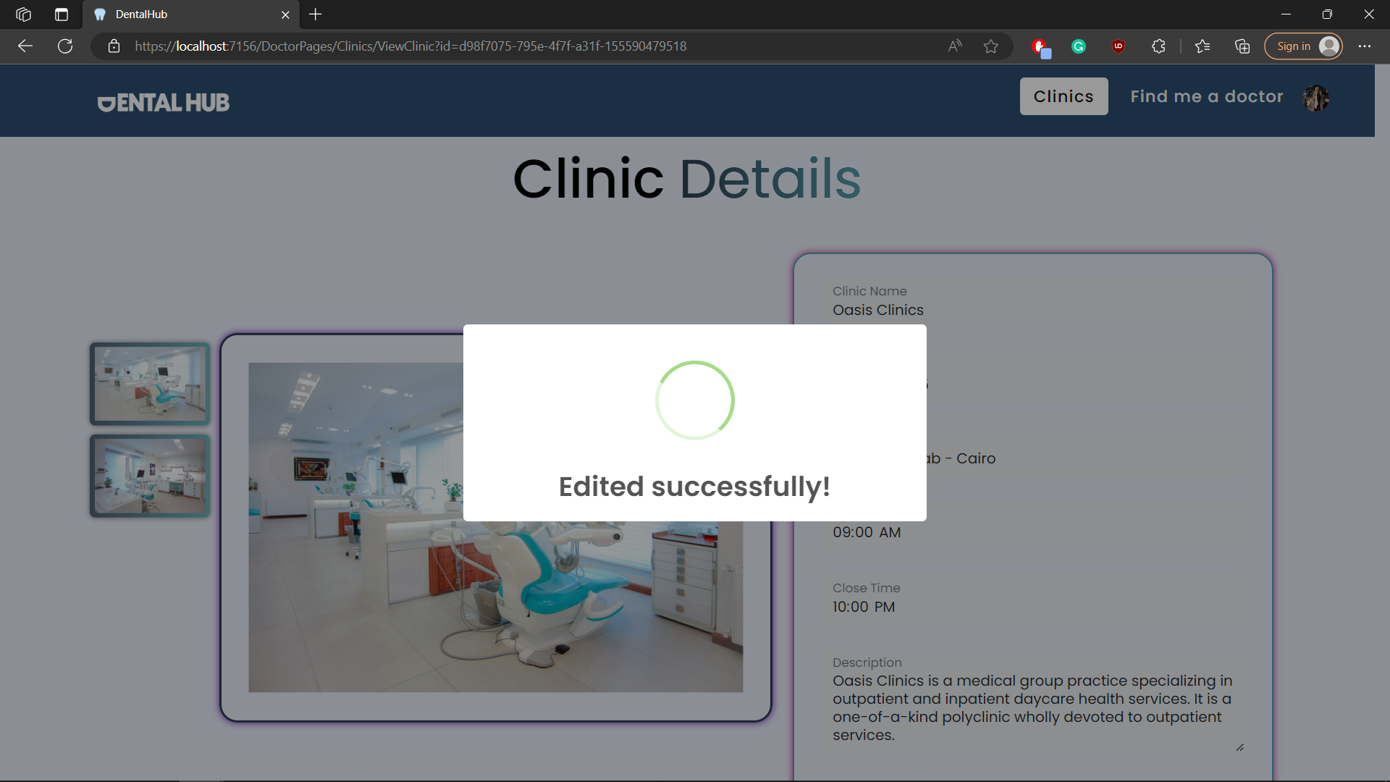

## Test case id : Clinic_Feedback_Delete

|  |  |  |  |
| --- | --- | --- | --- |
| Test Case | Test Steps | Test Data | Expected Result |
| Patient delets his own feedback | 1-Go to Clinic Page  2- Press view  3-press the 3 dots then delete |  | Feedback deleted successfully and changes clinic overall rating |

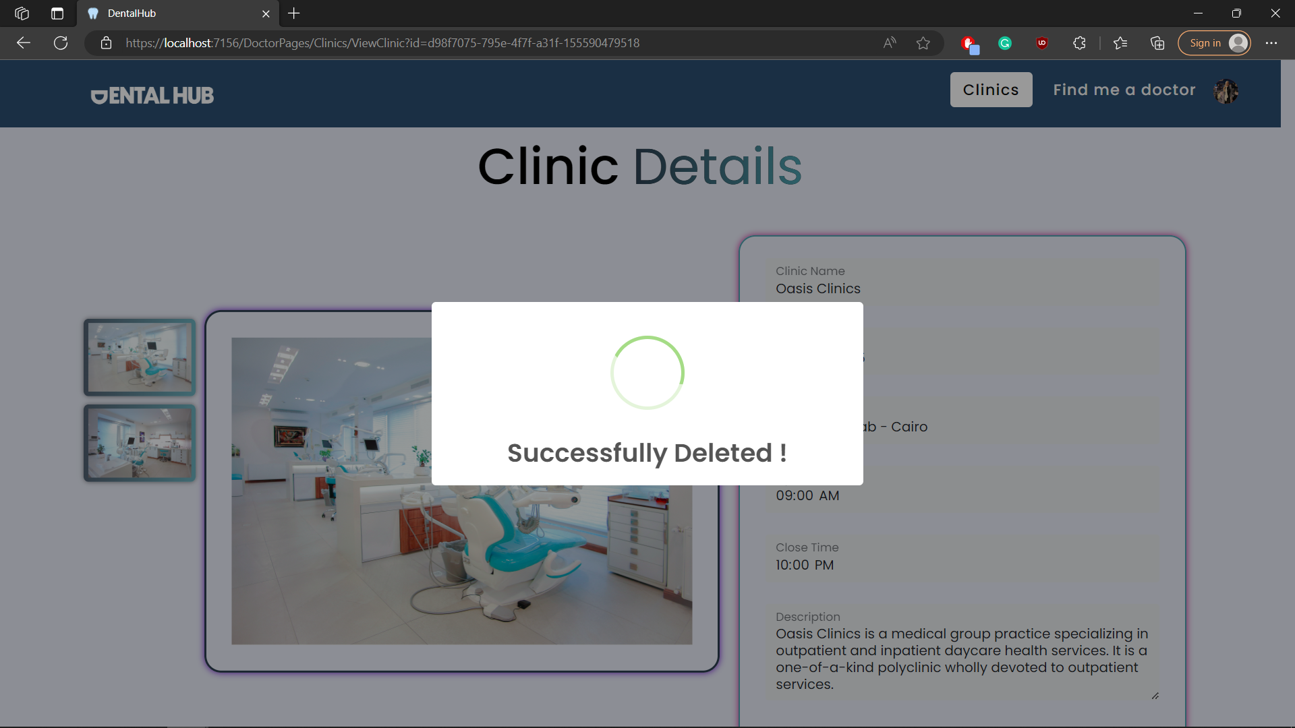

# Module Name : Job

## Test case id : Job_Display_All

|  |  |  |  |
| --- | --- | --- | --- |
| Test Case | Test Steps | Test Data | Expected Result |
| Dentist displays all jobs available | 1-Go to Job Page |  | All jobs displayed |

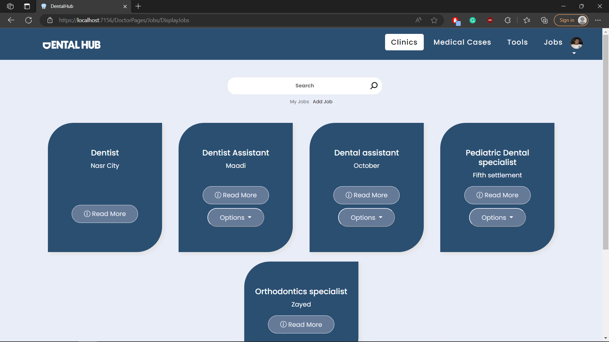

## Test case id : Job_Display_Mine

|  |  |  |  |
| --- | --- | --- | --- |
| Test Case | Test Steps | Test Data | Expected Result |
| Dentist displays all jobs that he posted | 1-Go to Job Page  2- press my jobs |  | Only his jobs displayed |

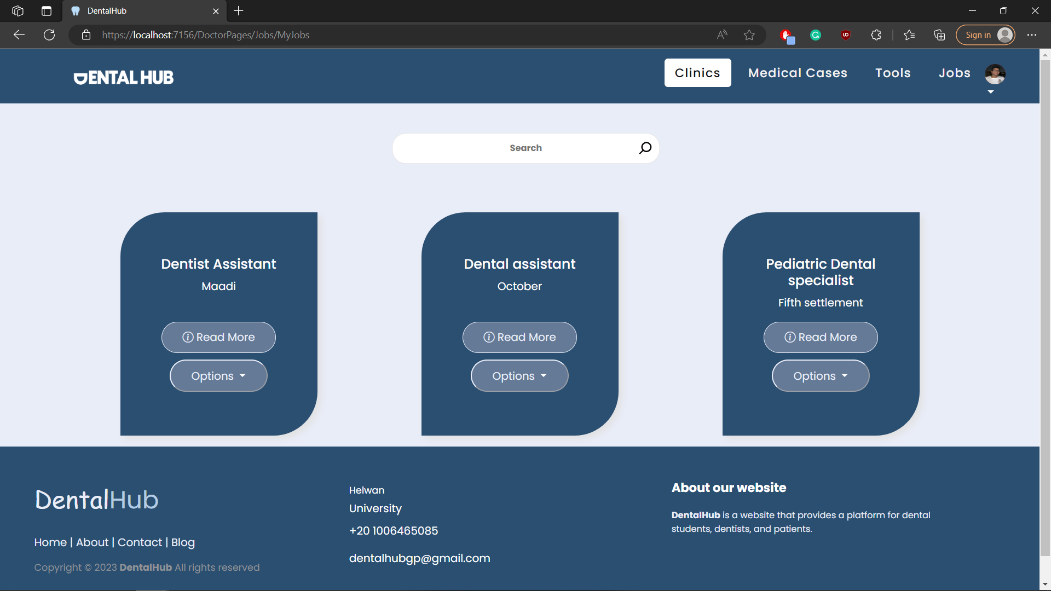

## Test case id : Job_Add_Incomplete

|  |  |  |  |
| --- | --- | --- | --- |
| Test Case | Test Steps | Test Data | Expected Result |
| Dentist adds a job but with incomplete required data | 1-Go to Job Page  2-press add job  3-enter data | Incomplete data | Form wont add  And shows error message |

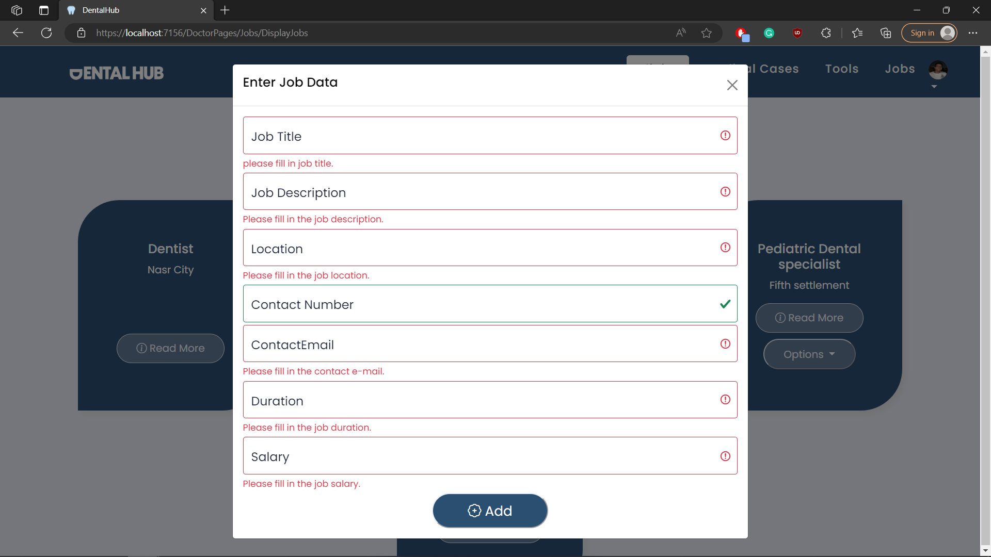

## Test case id : Job_Add_Valid

|  |  |  |  |
| --- | --- | --- | --- |
| Test Case | Test Steps | Test Data | Expected Result |
| Dentist adds a job with valid and complete data | 1-Go to Job Page  2-press add job  3-enter data | Complete / valid  data | Redirects to the same page with success message |

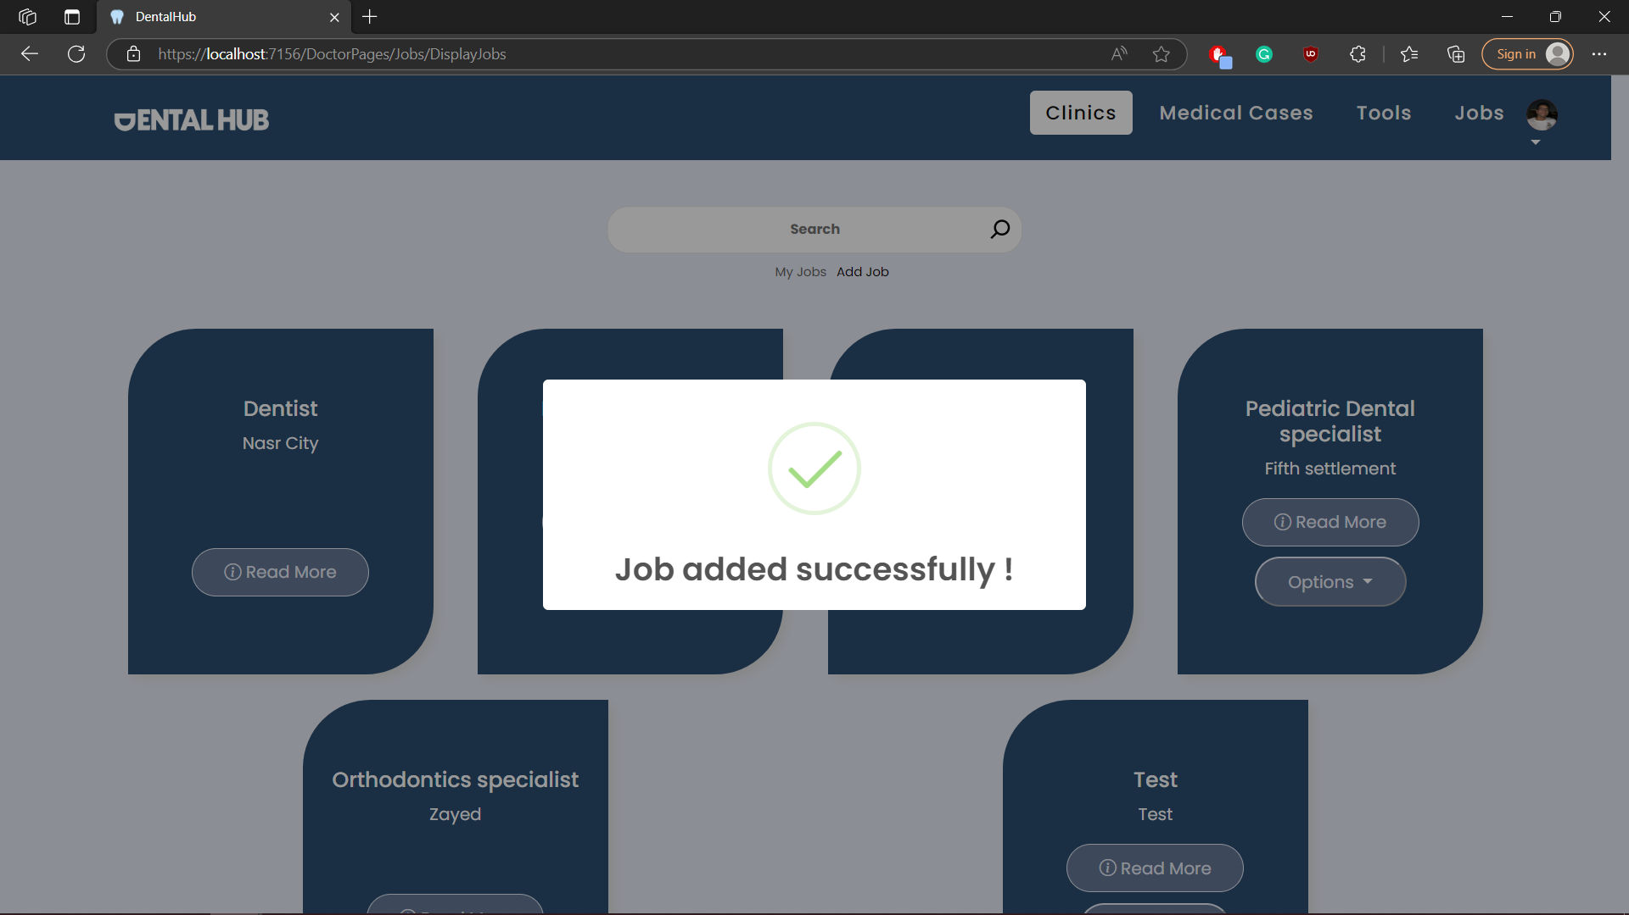

## Test case id : Job_Edit

|  |  |  |  |
| --- | --- | --- | --- |
| Test Case | Test Steps | Test Data | Expected Result |
| Dentist edits a job with valid and complete data | 1-Go to Job Page  2-press options then edit  3-enter data | Complete / valid  data | Redirects to the same page with success message |

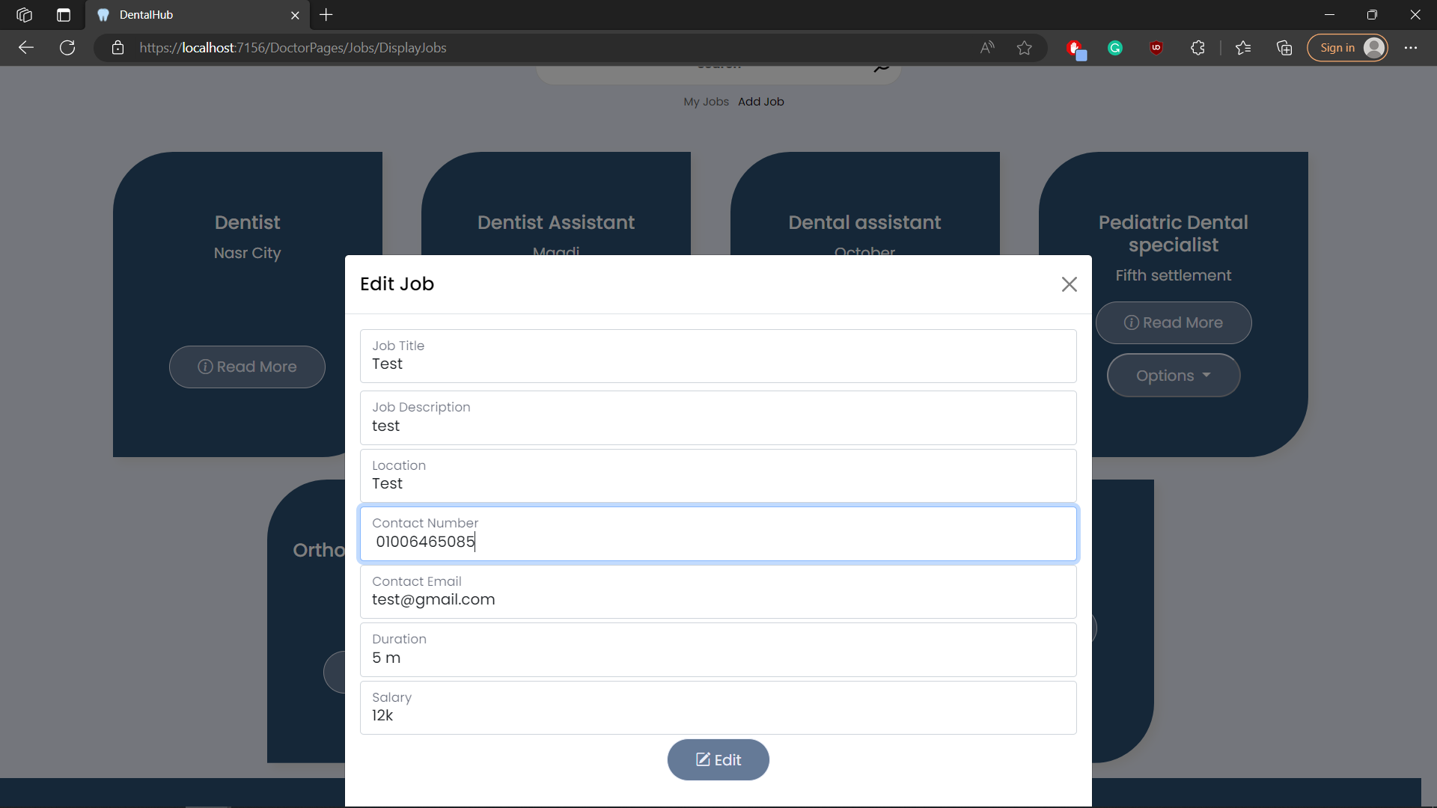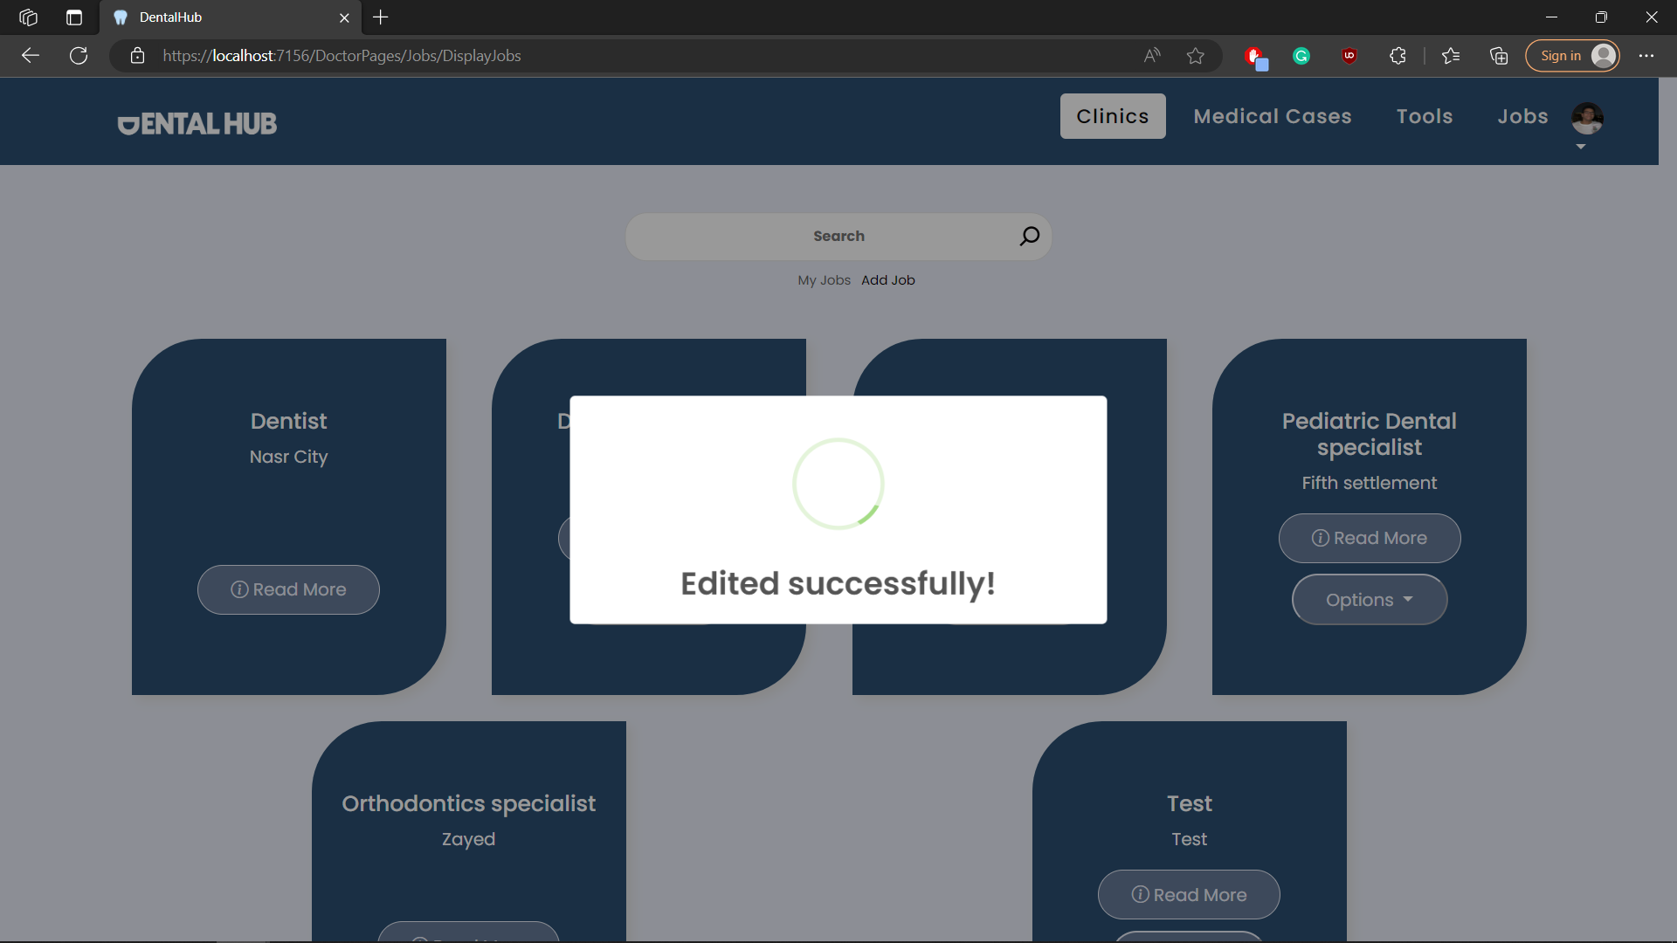

## Test case id : Job_Delete

|  |  |  |  |
| --- | --- | --- | --- |
| Test Case | Test Steps | Test Data | Expected Result |
| Dentist delets a job | 1-Go to Job Page  2-press options then delete |  | Redirects to the same page with success message |

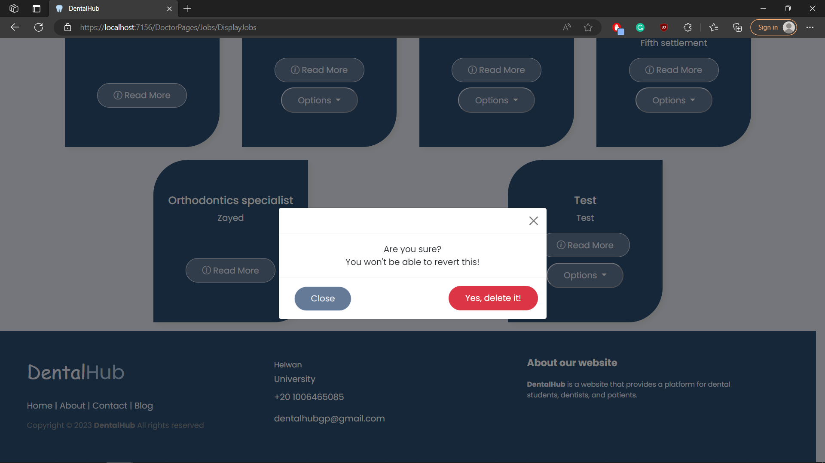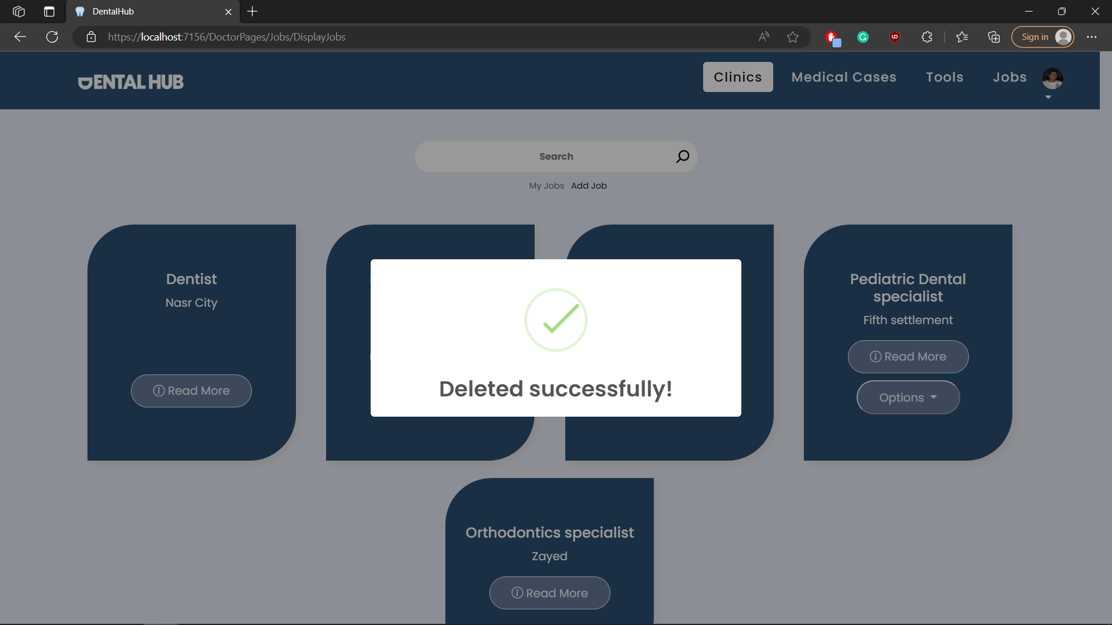

## Test case id : Job_View

|  |  |  |  |
| --- | --- | --- | --- |
| Test Case | Test Steps | Test Data | Expected Result |
| Dentist shows a single job information | 1-Go to Job Page  2-press read more |  | Shows job information |

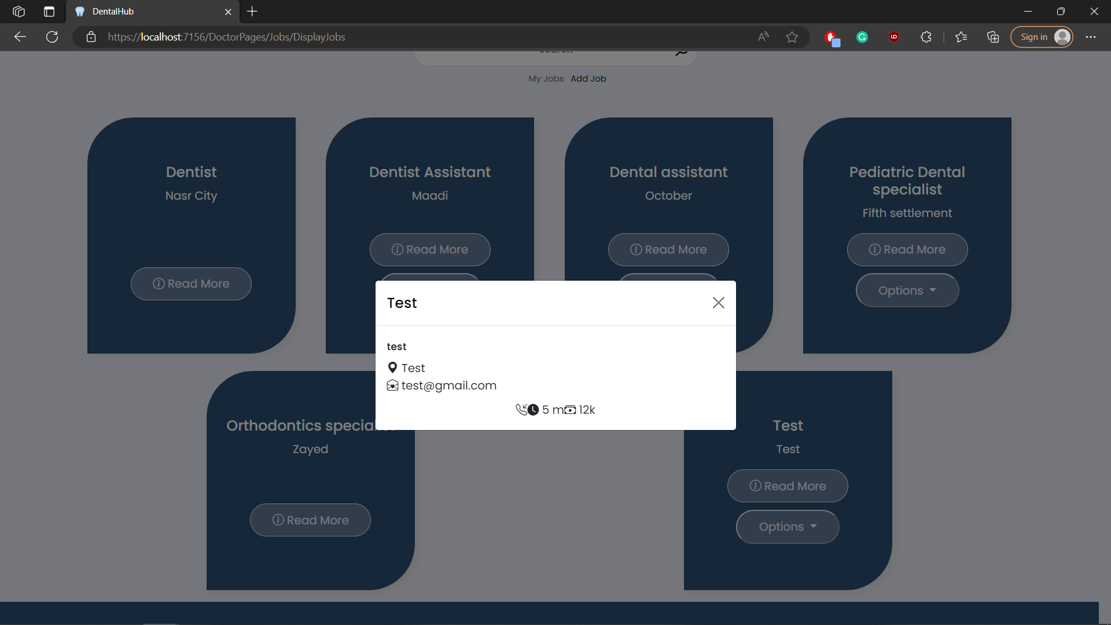

# Module Name : Medical Case

## Test case id : MedicalCase_Display_All

|  |  |  |  |
| --- | --- | --- | --- |
| Test Case | Test Steps | Test Data | Expected Result |
| Dentist shows all medical cases | 1-Go to Medical Cases Page |  | Shows all medical Cases |

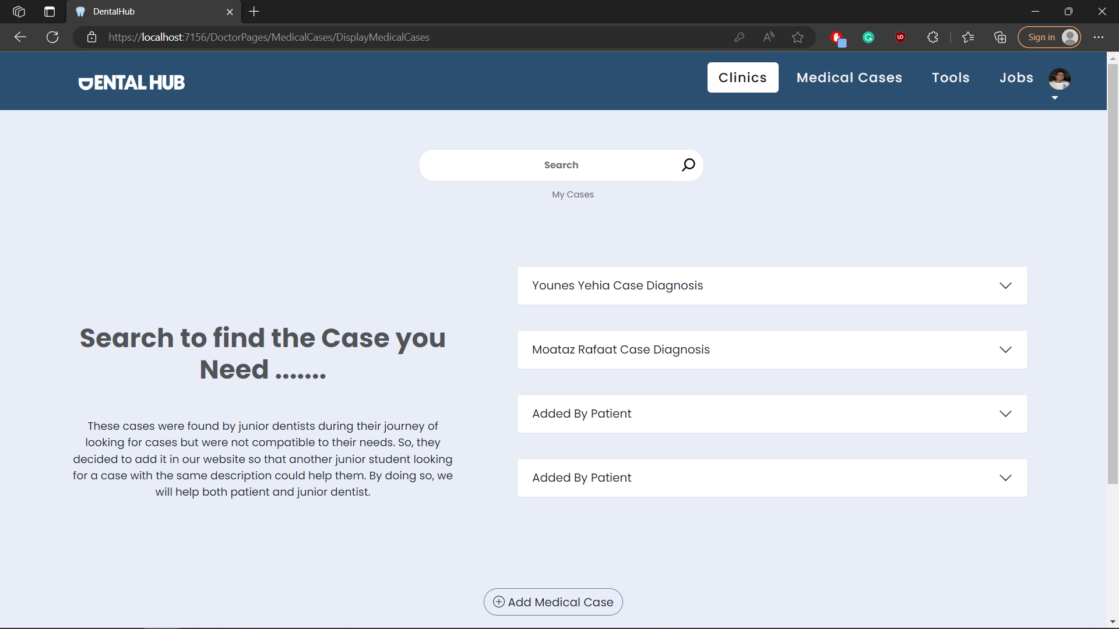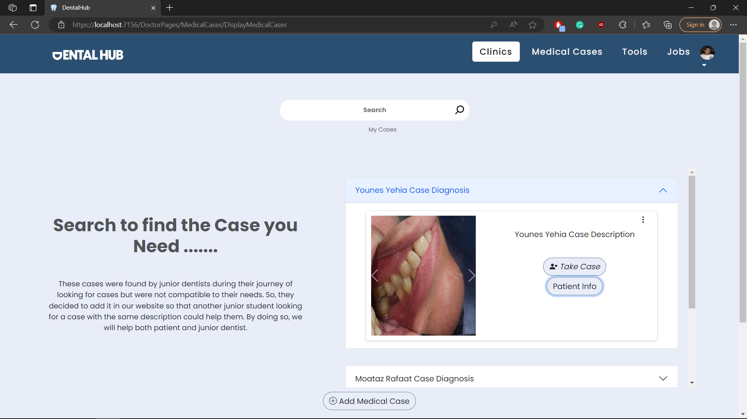

## Test case id : MedicalCase_Display_Mine

|  |  |  |  |
| --- | --- | --- | --- |
| Test Case | Test Steps | Test Data | Expected Result |
| Dentist shows only his medical cases | 1-Go to Medical Cases Page  2-press my cases |  | Shows only his cases |

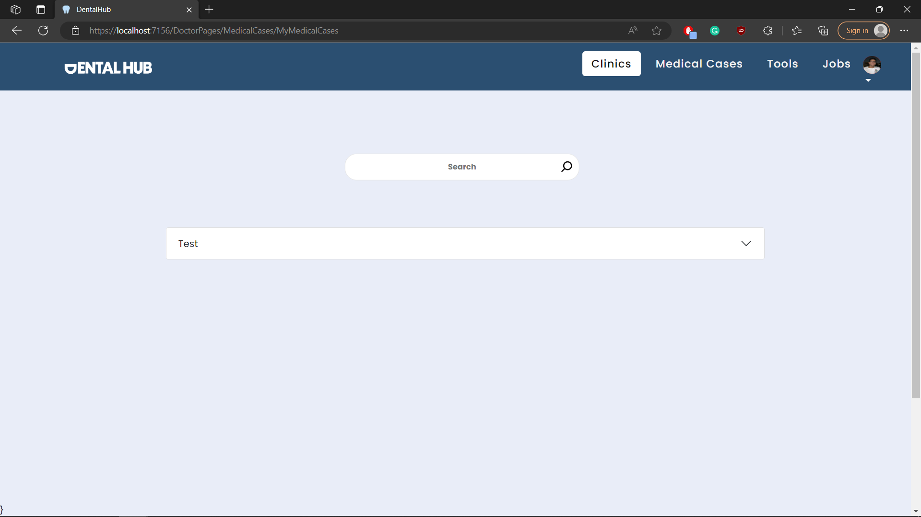

## Test case id : MedicalCase_Add_Incomplete

|  |  |  |  |
| --- | --- | --- | --- |
| Test Case | Test Steps | Test Data | Expected Result |
| Dentist adds a case but with incomplete data | 1-Go to Medical Cases Page  2-press add medical case  3-enter data | Incomplete case data | Prevents adding and shows error message |

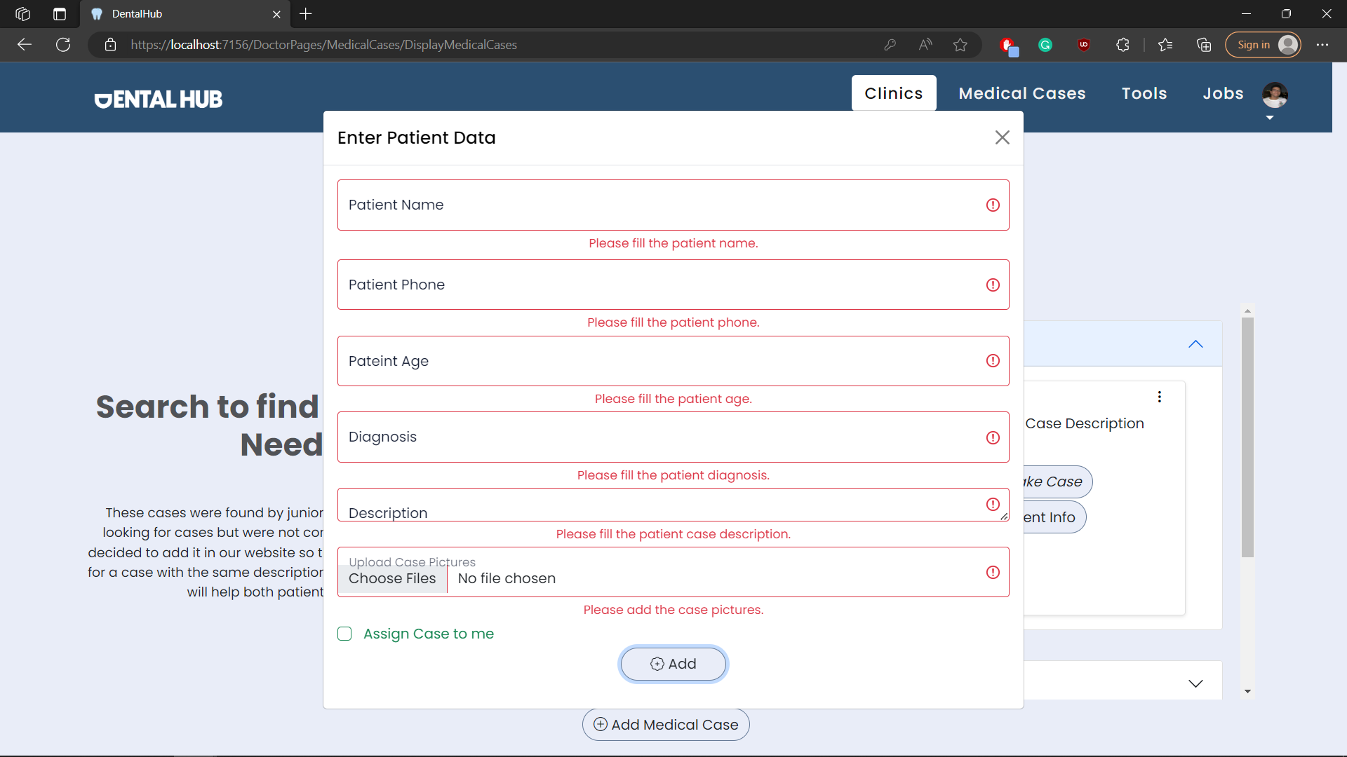

## Test case id : MedicalCase_Add_Valid

|  |  |  |  |
| --- | --- | --- | --- |
| Test Case | Test Steps | Test Data | Expected Result |
| Dentist adds a case with valid data | 1-Go to Medical Cases Page  2-press add medical case  3-enter data | Valid case data | Redirects to the same page with success message |

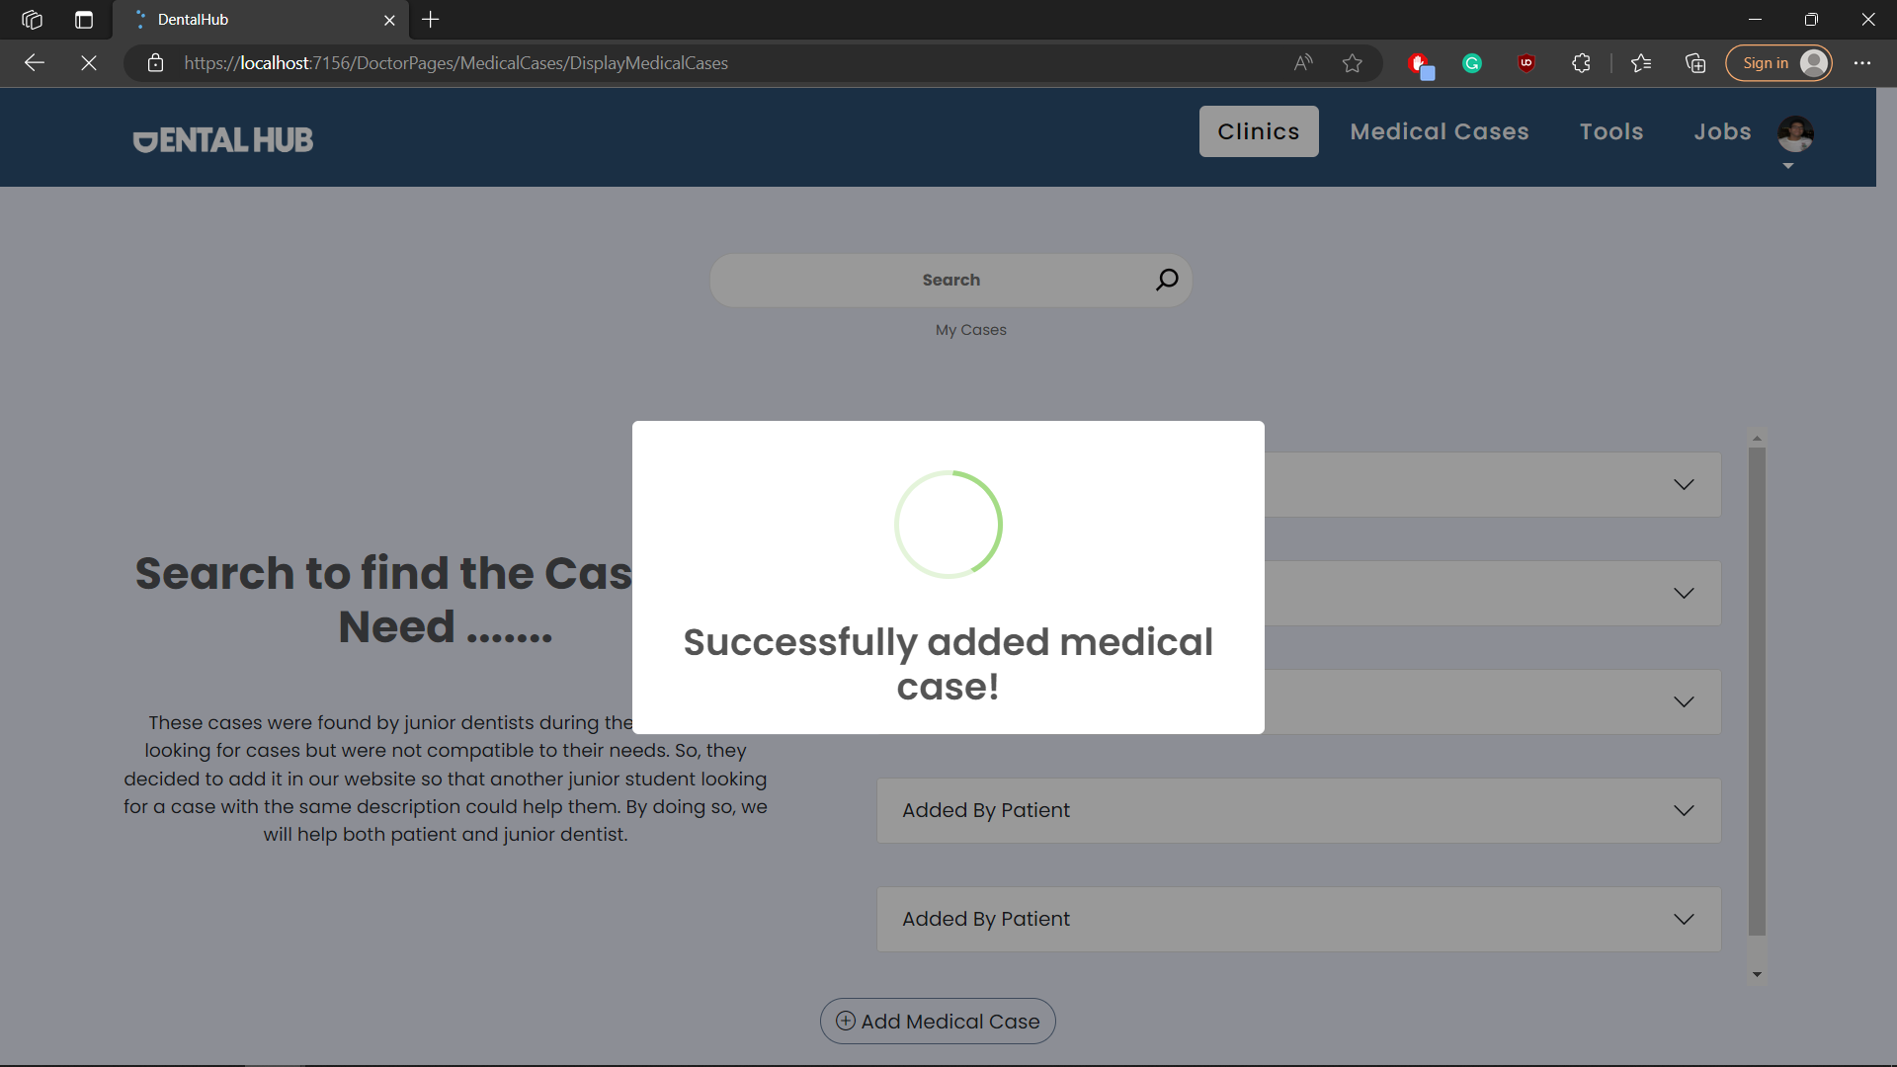

## Test case id : MedicalCase_View

|  |  |  |  |
| --- | --- | --- | --- |
| Test Case | Test Steps | Test Data | Expected Result |
| Dentist wants to see patient data | 1-Go to Medical Cases Page  2-open the case you want  3-press patient info |  | Shows patient info |

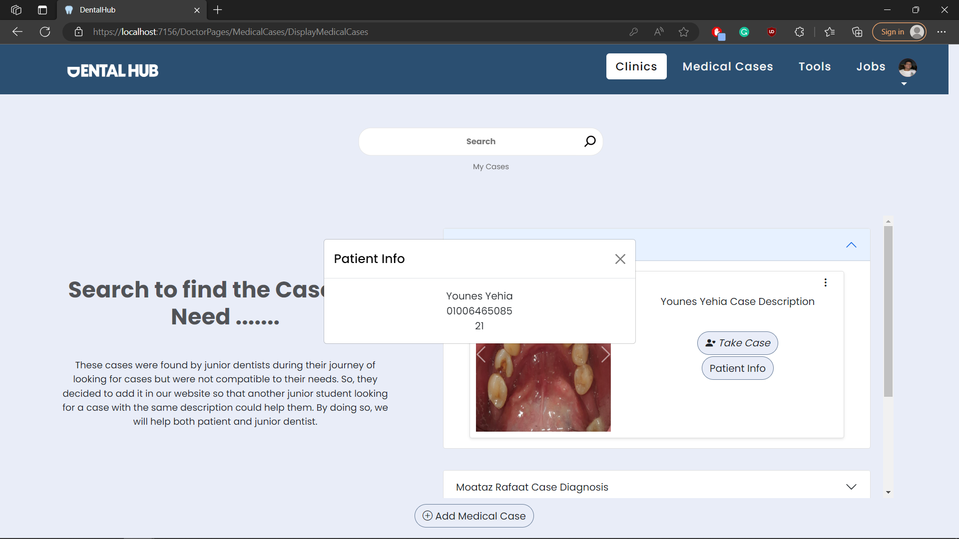

## Test case id : MedicalCase_FinishCase_Incomplete

|  |  |  |  |
| --- | --- | --- | --- |
| Test Case | Test Steps | Test Data | Expected Result |
| Dentist finishs a case but with incomplete data | 1-Go to My Medical Cases Page  2-chose the case you want and press finish  3-enter data | Incomplete case data | Prevents adding and shows error message |

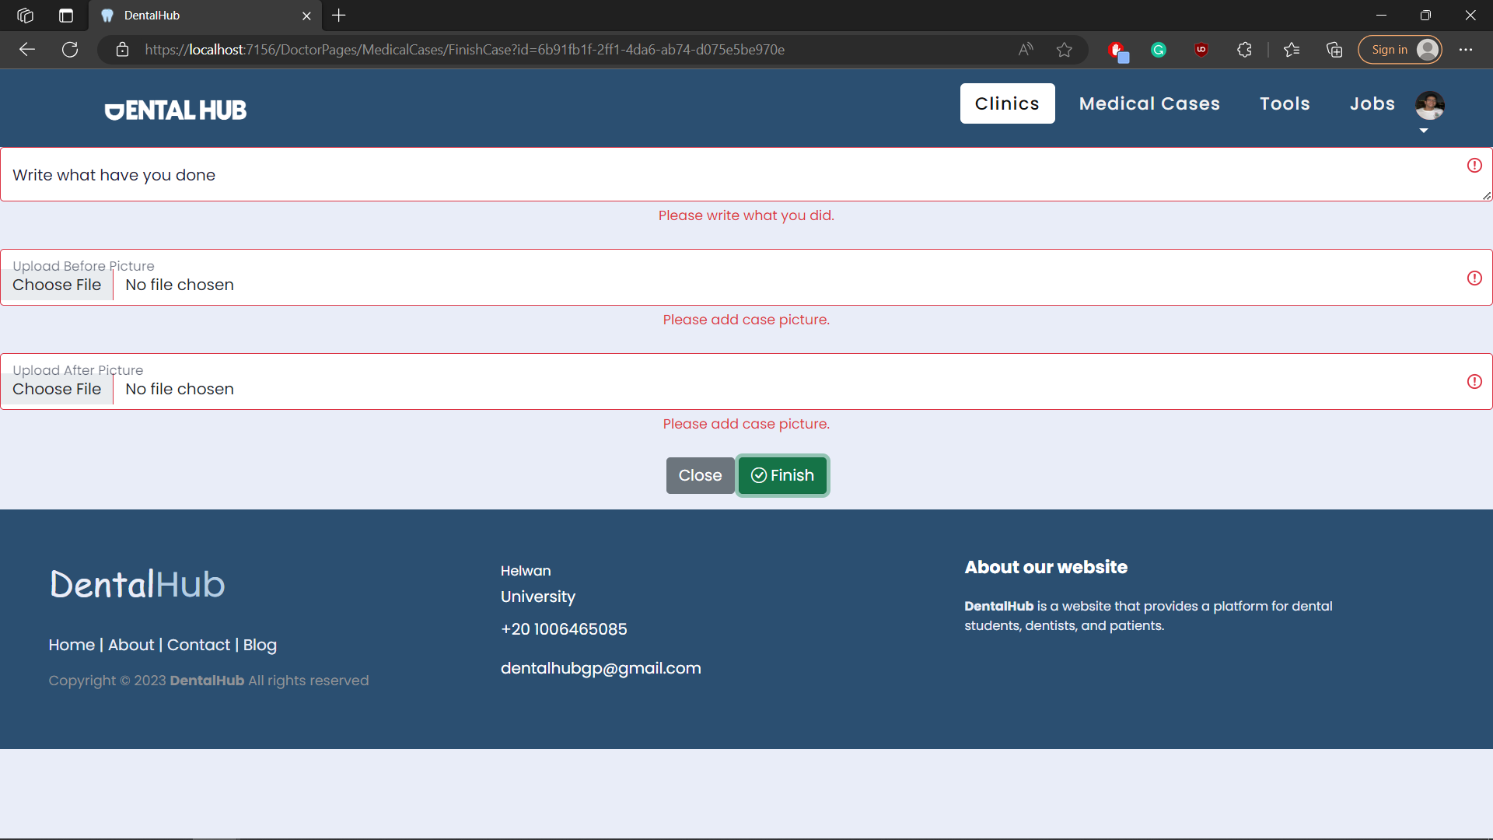

## Test case id : MedicalCase_FinishCase_Valid

|  |  |  |  |
| --- | --- | --- | --- |
| Test Case | Test Steps | Test Data | Expected Result |
| Dentist finishs a case with valid data | 1-Go to My Medical Cases Page  2-chose the case you want and press finish  3-enter data | Enter valid data | Redirects to the same page with success message |

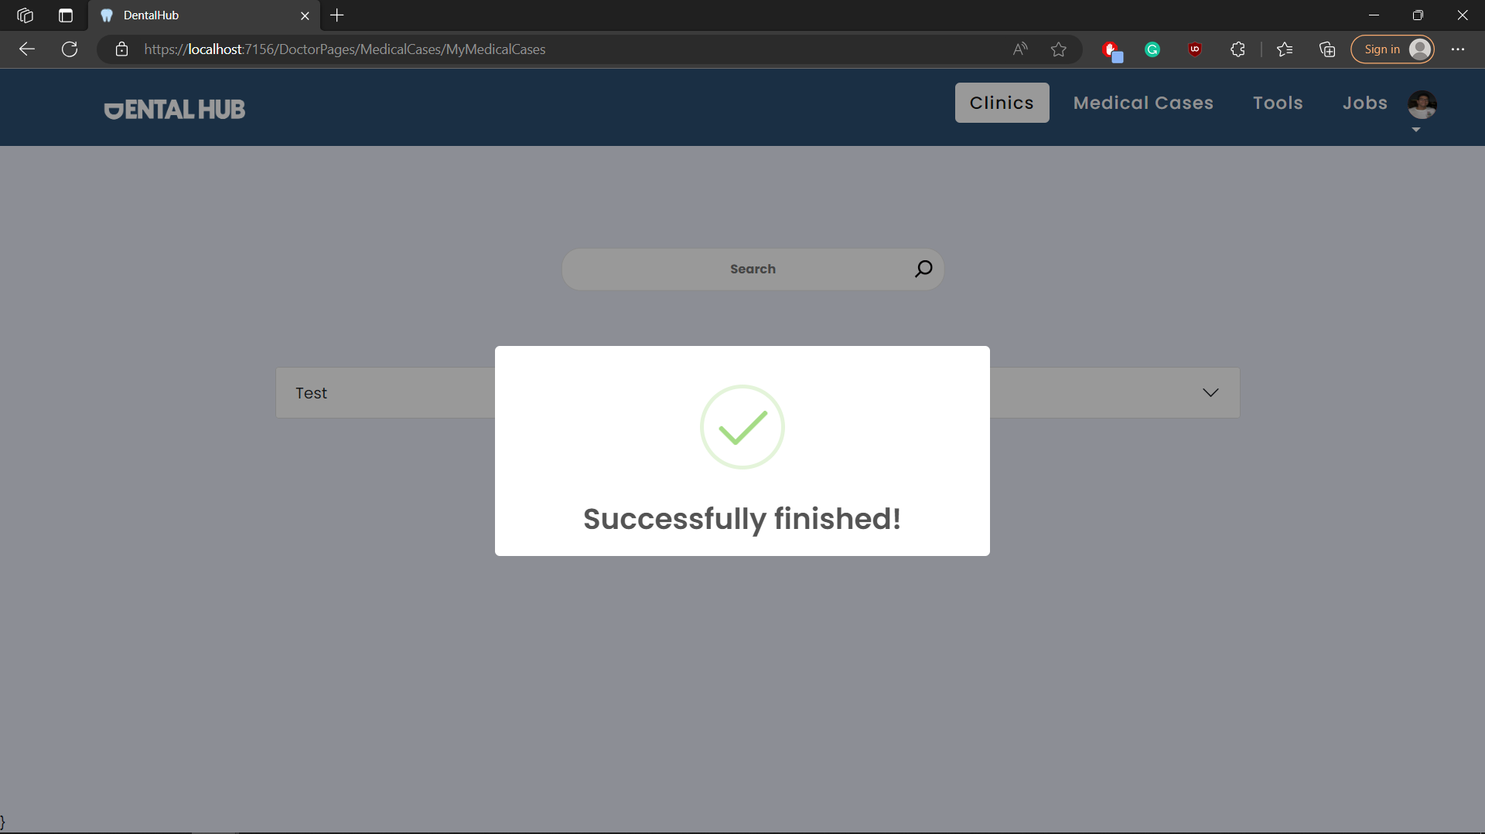

## Test case id : MedicalCase_Take_Case

|  |  |  |  |
| --- | --- | --- | --- |
| Test Case | Test Steps | Test Data | Expected Result |
| Dentist assigns a case to him | 1-Go to Medical Cases Page  2-chose the case you want and press take case |  | Redirects to my medical cases page with success message |

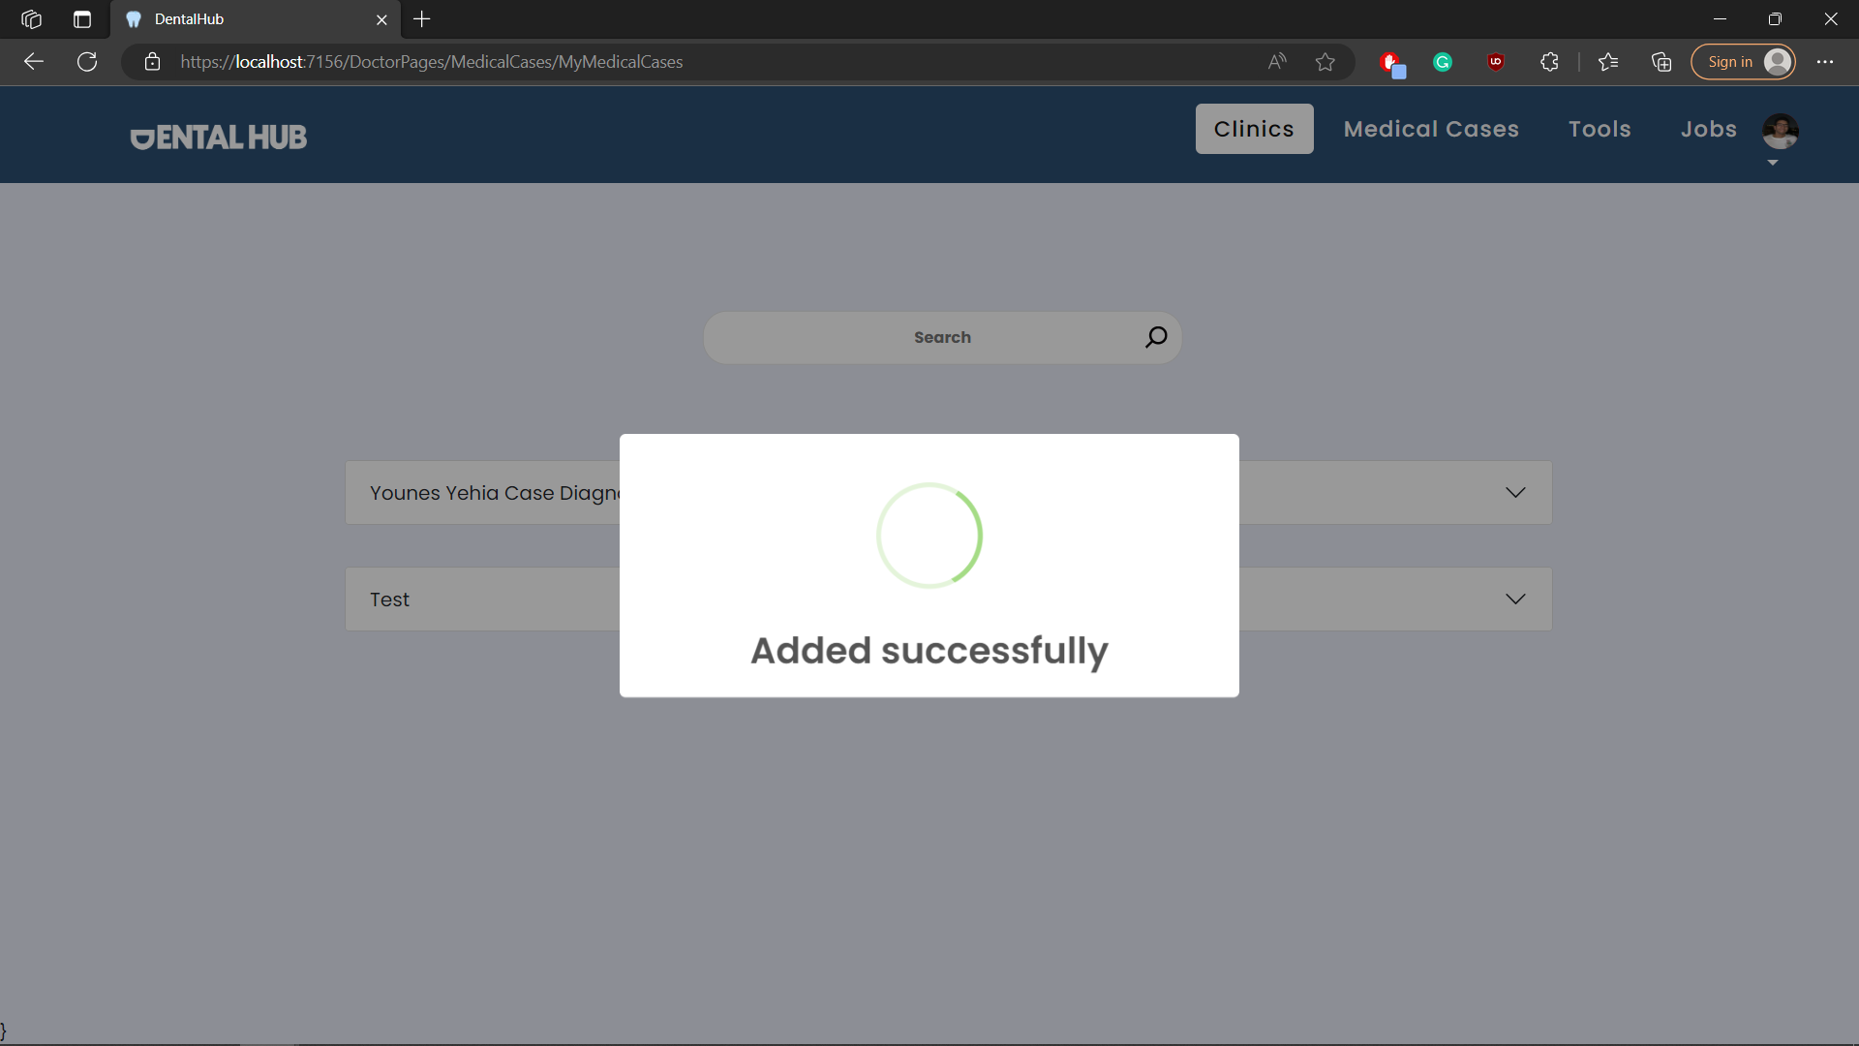

## Test case id : MedicalCase_Cancel_Case

|  |  |  |  |
| --- | --- | --- | --- |
| Test Case | Test Steps | Test Data | Expected Result |
| Dentist un assign a case | 1-Go to My Medical Cases Page  2-chose the case you want and press cancel |  | Redirects to my medical cases page with success message |

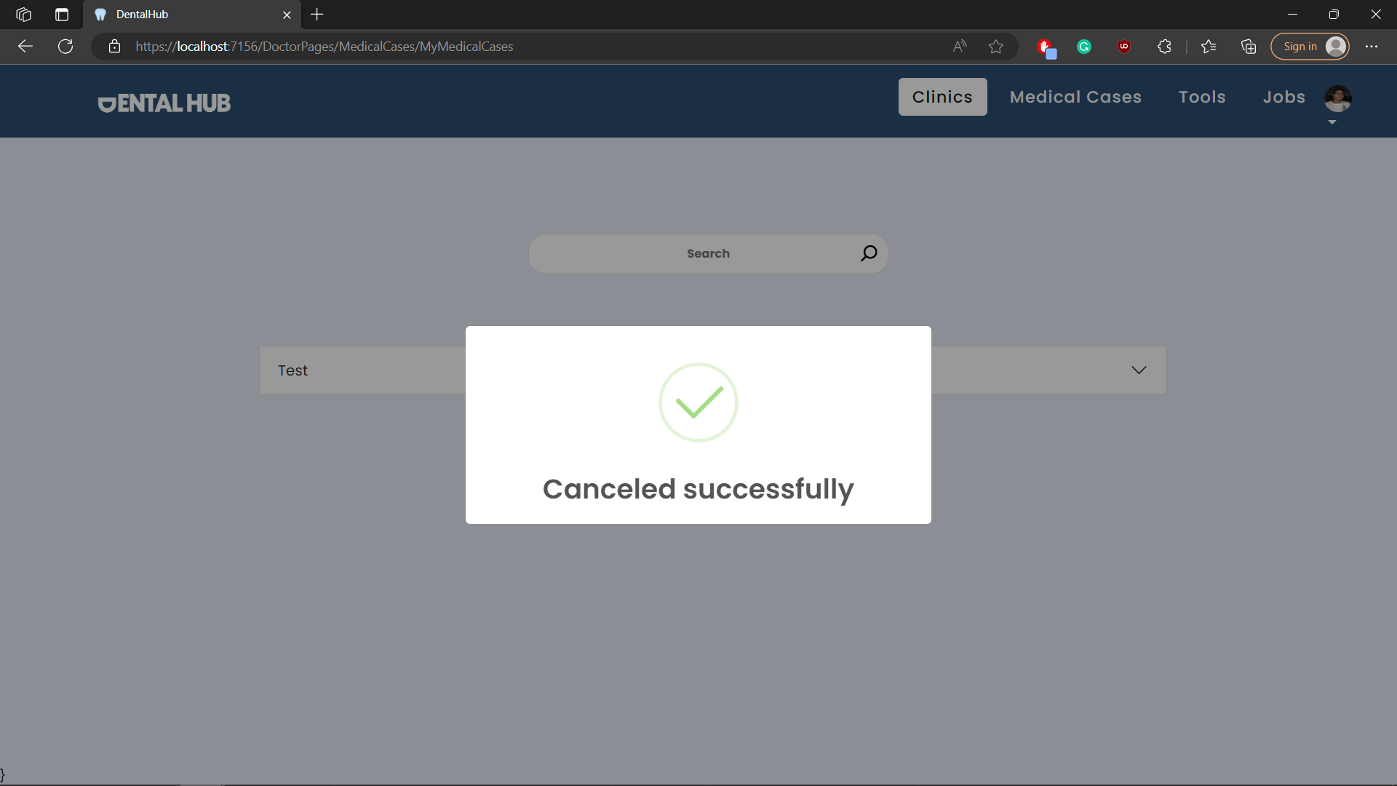

## Test case id : MedicalCase_Edit_Case

|  |  |  |  |
| --- | --- | --- | --- |
| Test Case | Test Steps | Test Data | Expected Result |
| Dentist Edits his own case | 1-Go to Medical Cases / my medical cases Page  2-chose the case you want and press the 3 dots  3-press edit | Enter valid /complete data | Redirects to the same page with success message |

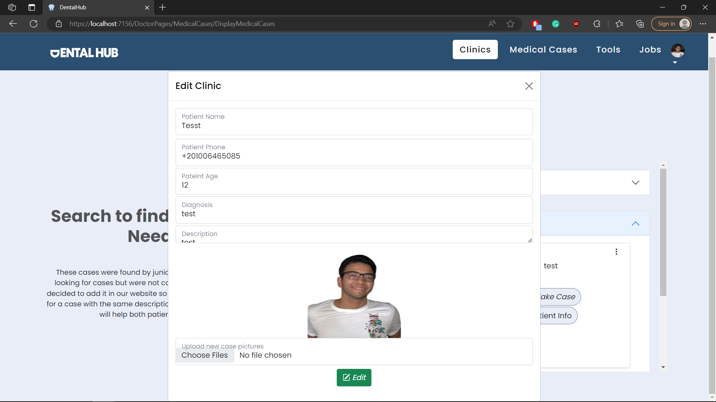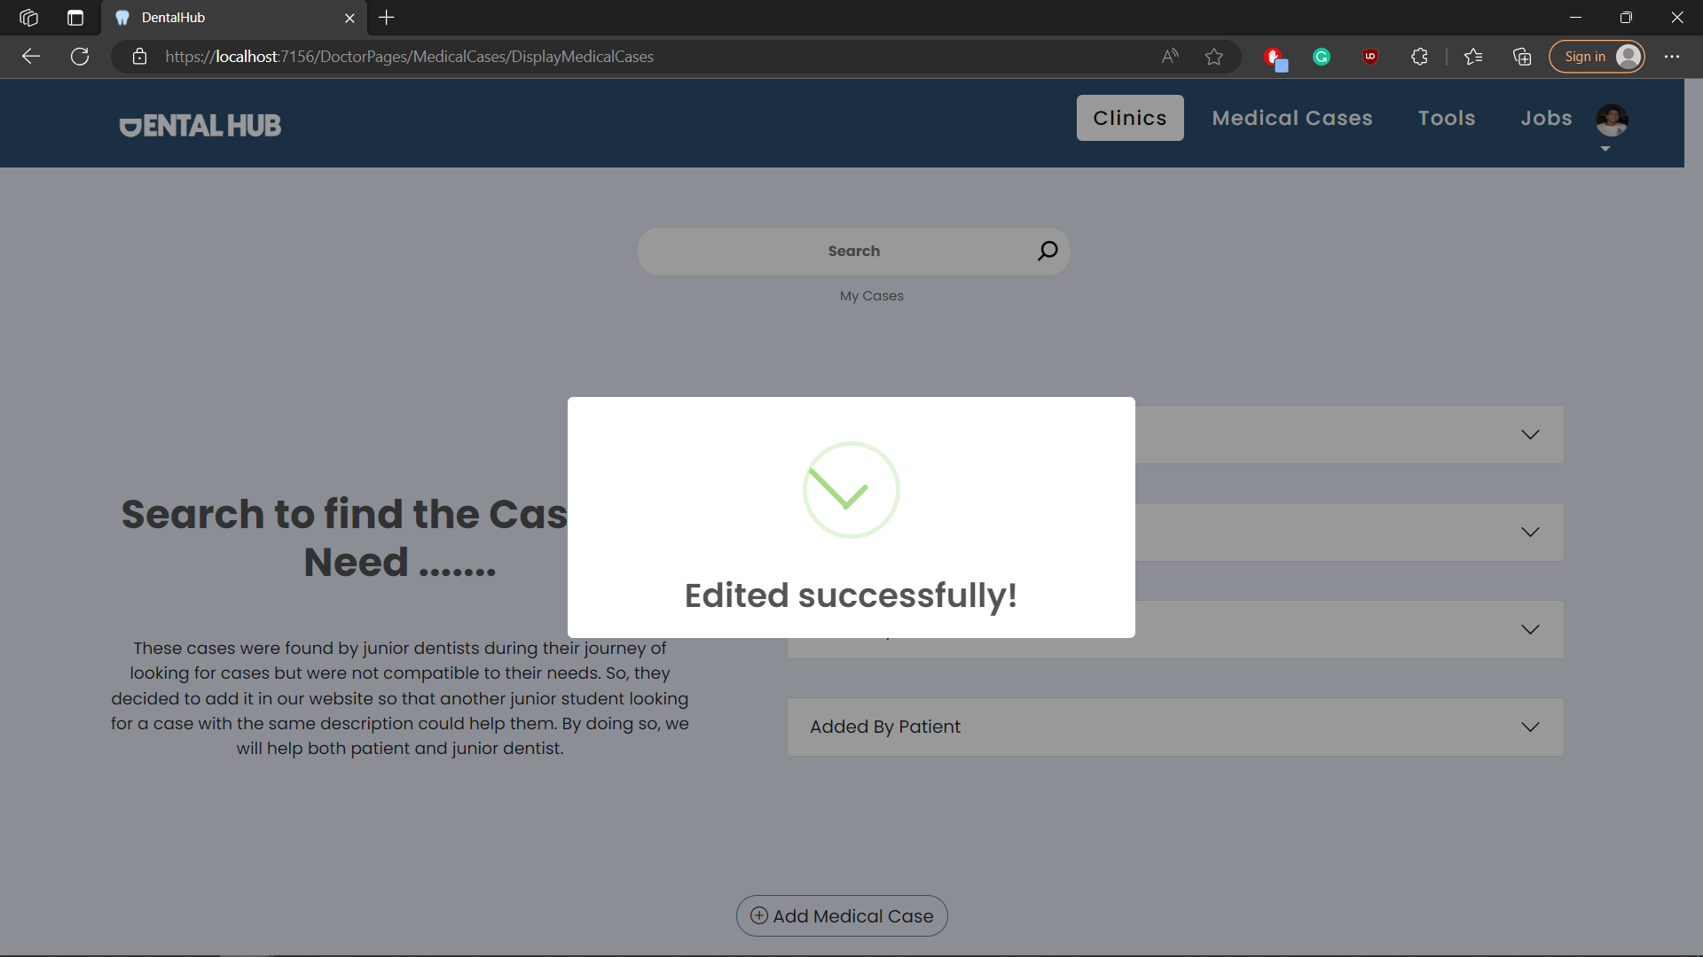

## Test case id : MedicalCase_Delete_Case

|  |  |  |  |
| --- | --- | --- | --- |
| Test Case | Test Steps | Test Data | Expected Result |
| Dentist delets his own case | 1-Go to Medical Cases / my medical cases Page  2-chose the case you want and press the 3 dots  3-press delete |  | Redirects to the same page with success message |

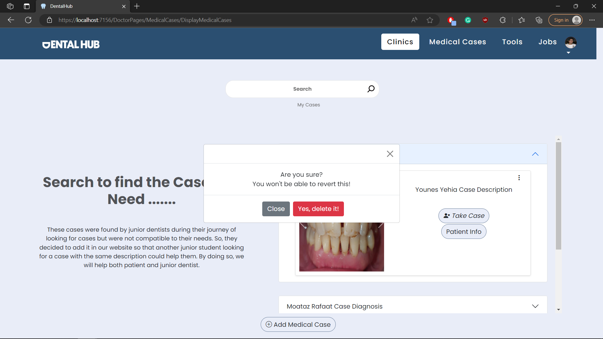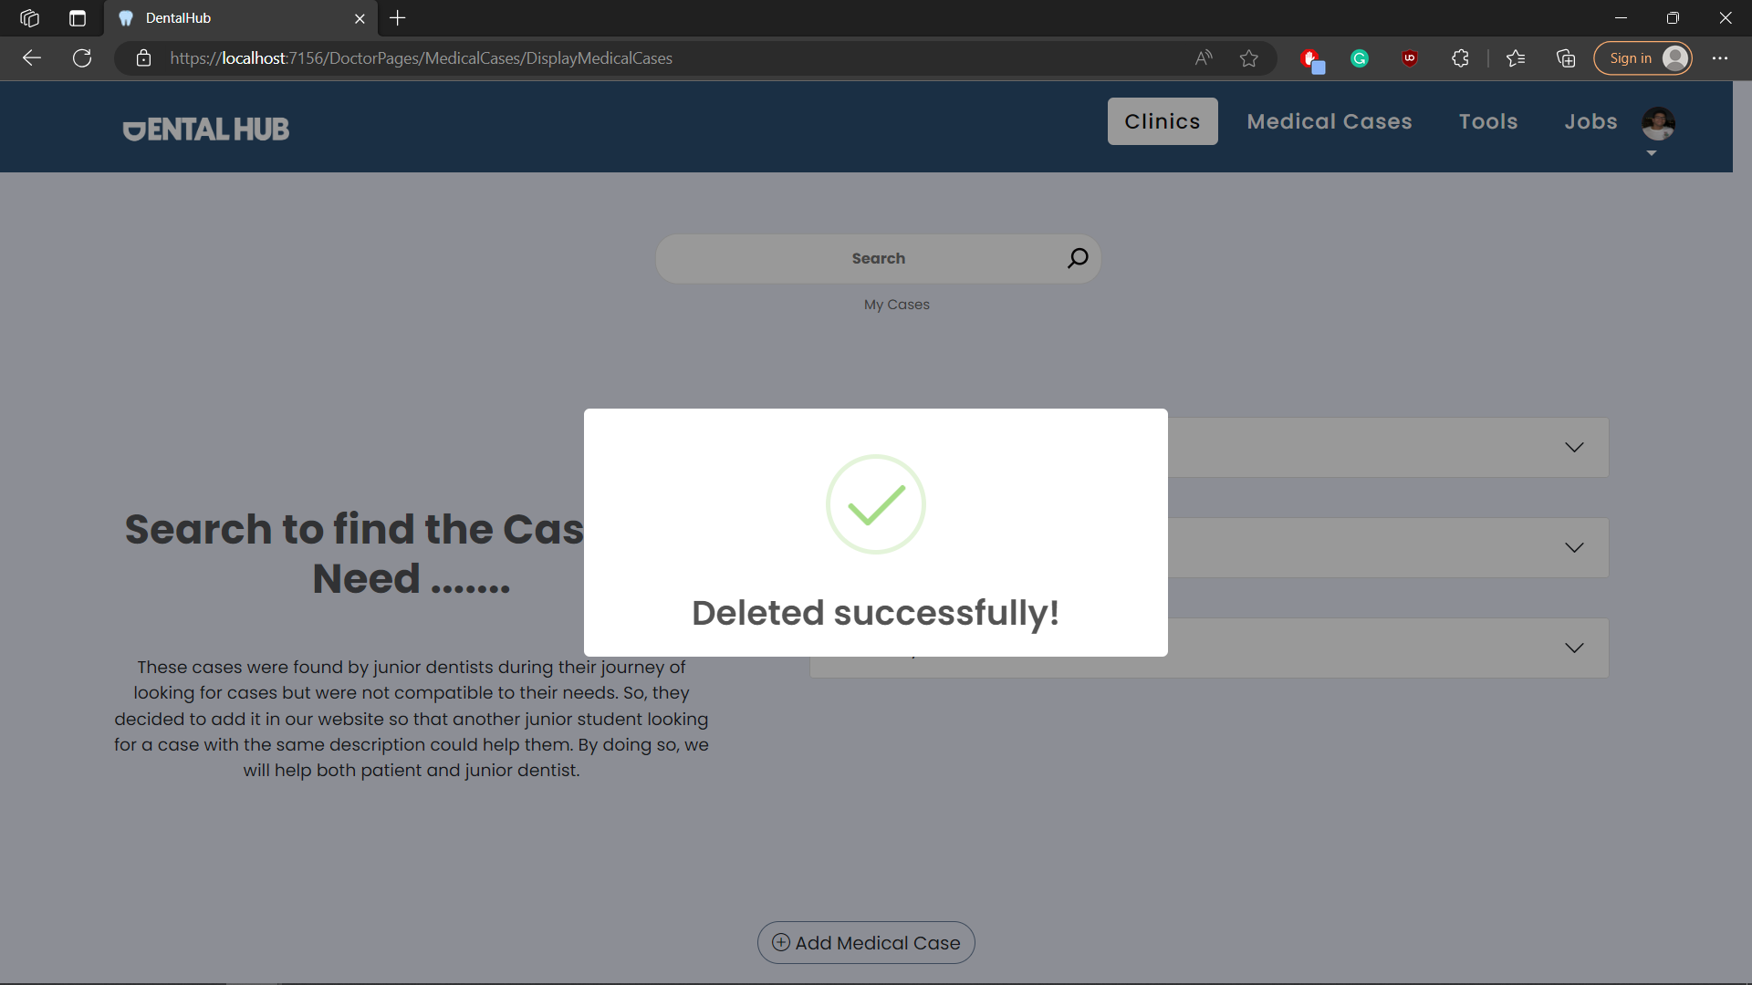

# Module Name : Tools

## Test case id : Tools_Display_All

|  |  |  |  |
| --- | --- | --- | --- |
| Test Case | Test Steps | Test Data | Expected Result |
| Dentist displays all tools available | 1-Go to Tools page |  | Shows all tools |

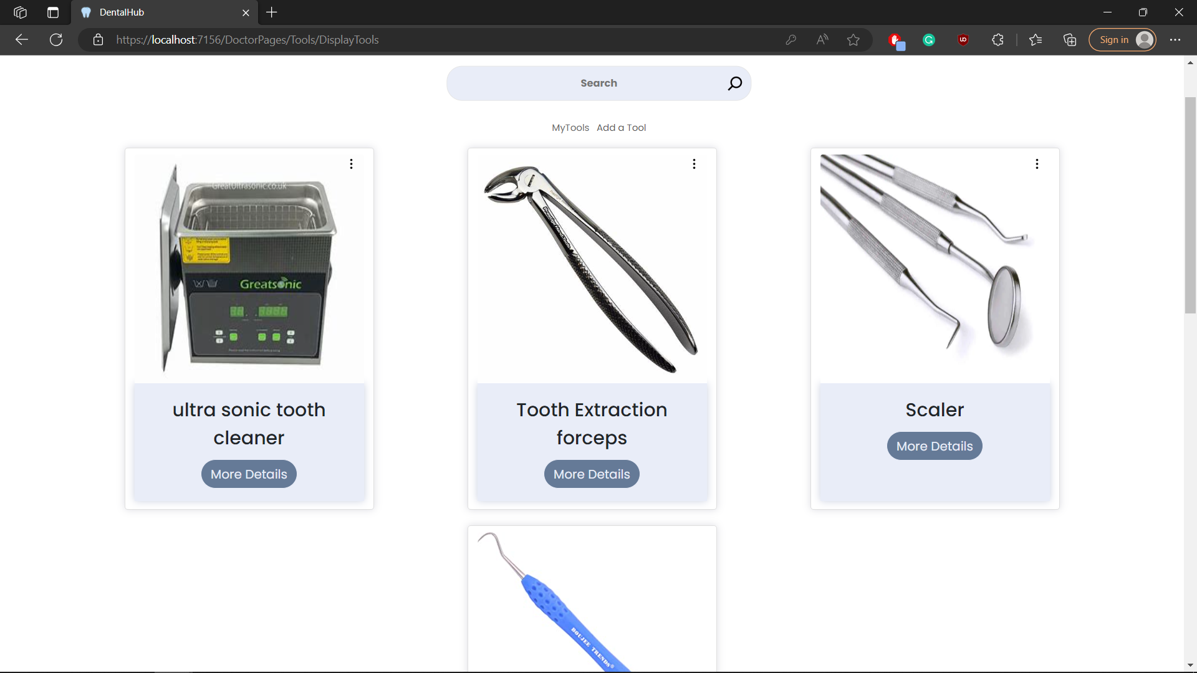

## Test case id : Tools_Display_Mine

|  |  |  |  |
| --- | --- | --- | --- |
| Test Case | Test Steps | Test Data | Expected Result |
| Dentist displays only his tools | 1-Go to Tools page  2-press my tools |  | Shows only his tools |

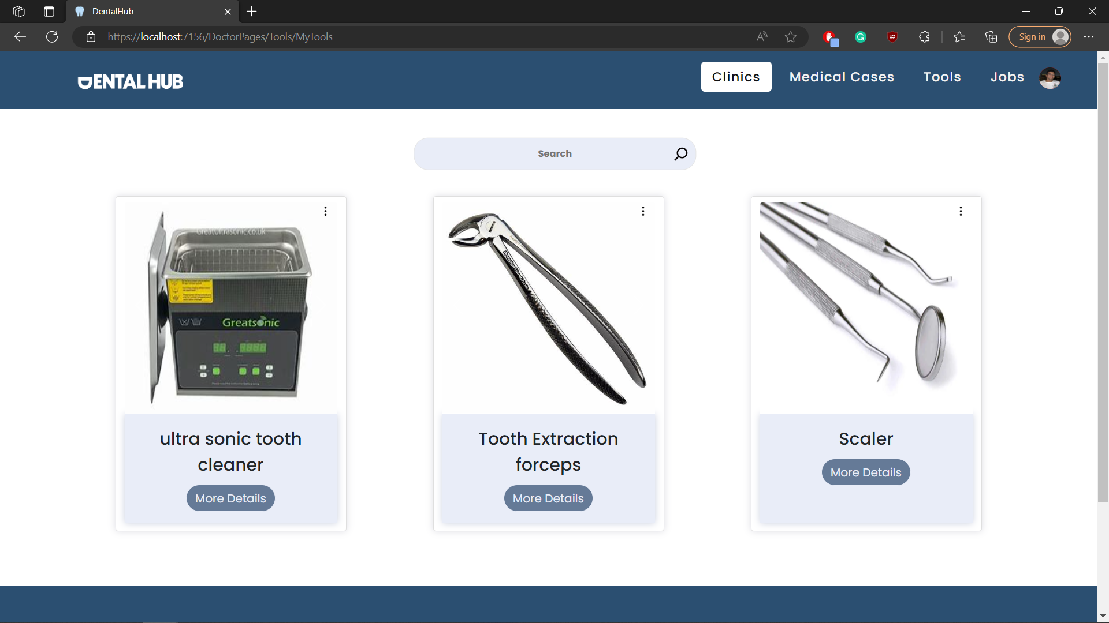

## Test case id : Tools_Add_Incomplete

|  |  |  |  |
| --- | --- | --- | --- |
| Test Case | Test Steps | Test Data | Expected Result |
| Dentist adds a tool but with incomplete data | 1-Go to Tools page  2-press add tool  3-enter data | Enter incomplete data | Prevents adding and shows error message |

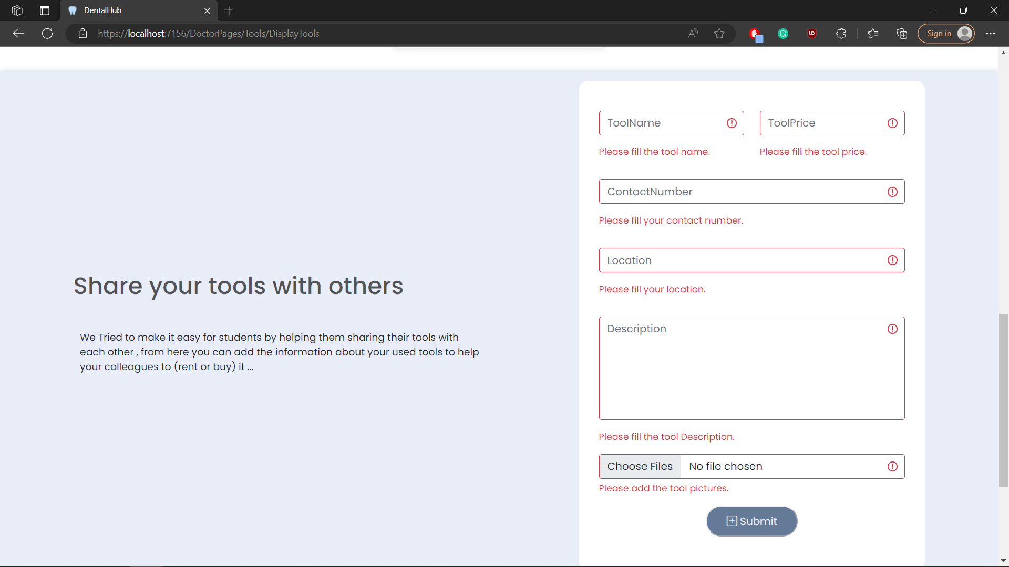

## Test case id : Tools_Add_valid

|  |  |  |  |
| --- | --- | --- | --- |
| Test Case | Test Steps | Test Data | Expected Result |
| Dentist adds a tool with valid data | 1-Go to Tools page  2-press add tool  3-enter data | Enter valid data | Redirects to the same page with success message |

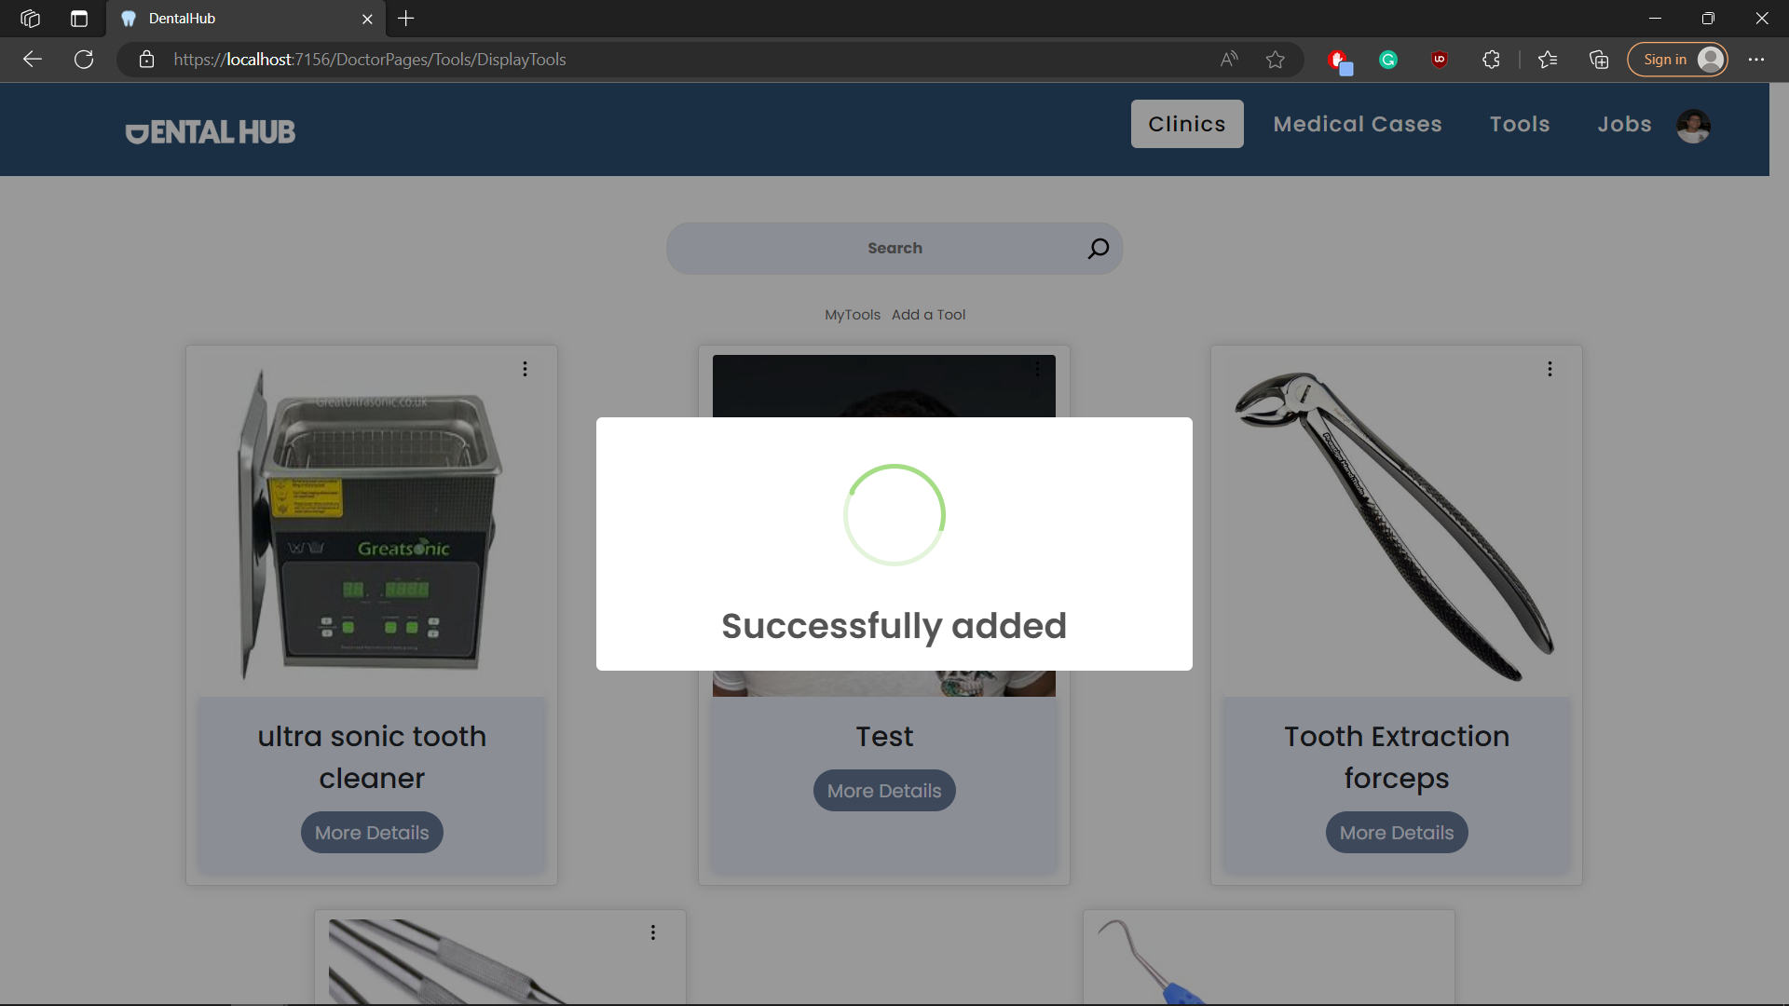

## Test case id : Tools_Edit

|  |  |  |  |
| --- | --- | --- | --- |
| Test Case | Test Steps | Test Data | Expected Result |
| Dentist edits his own tool | 1-Go to Tools / my tools page  2-chose the tool you want and press the 3 dots  3-press edit | Enter valid / complete data | Redirects to the same page with success message |

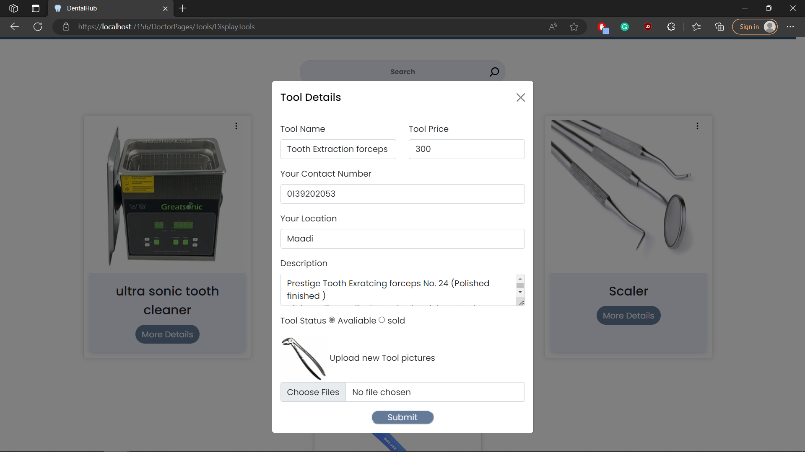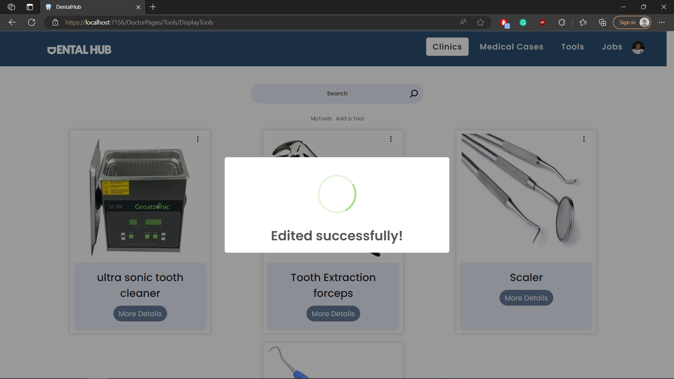

## Test case id : Tools_Delete

|  |  |  |  |
| --- | --- | --- | --- |
| Test Case | Test Steps | Test Data | Expected Result |
| Dentist delets his own tool | 1-Go to Tools / my tools page  2-chose the tool you want and press the 3 dots  3-press delete |  | Redirects to the same page with success message |

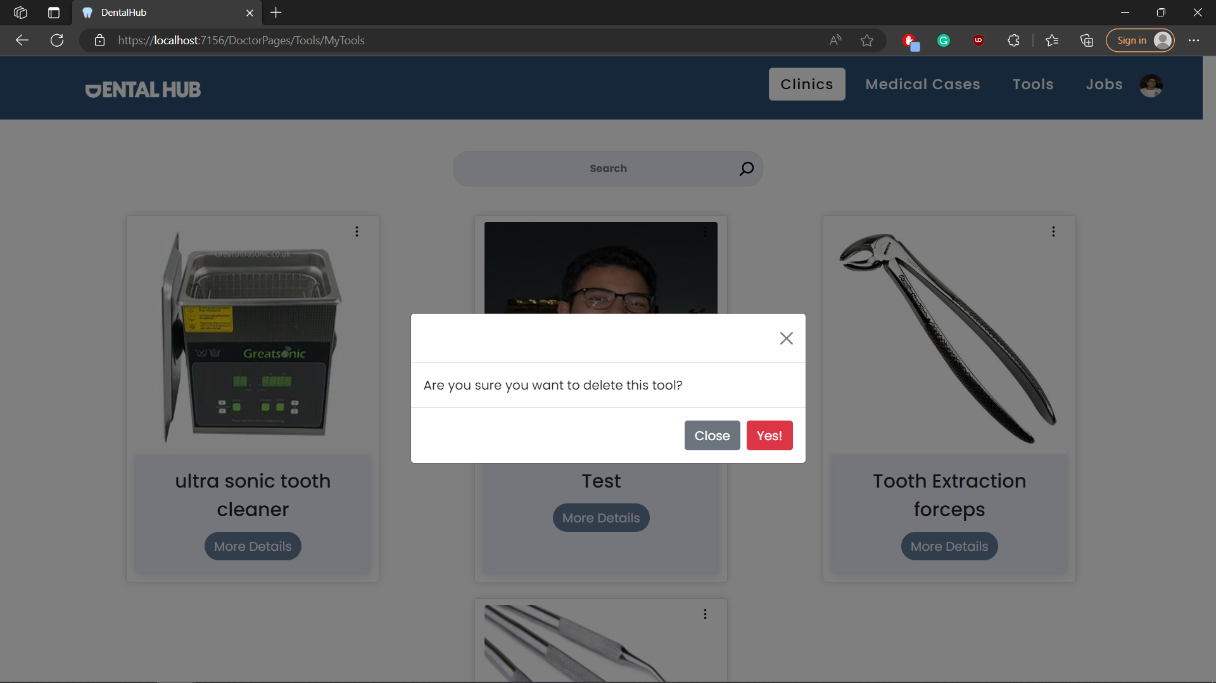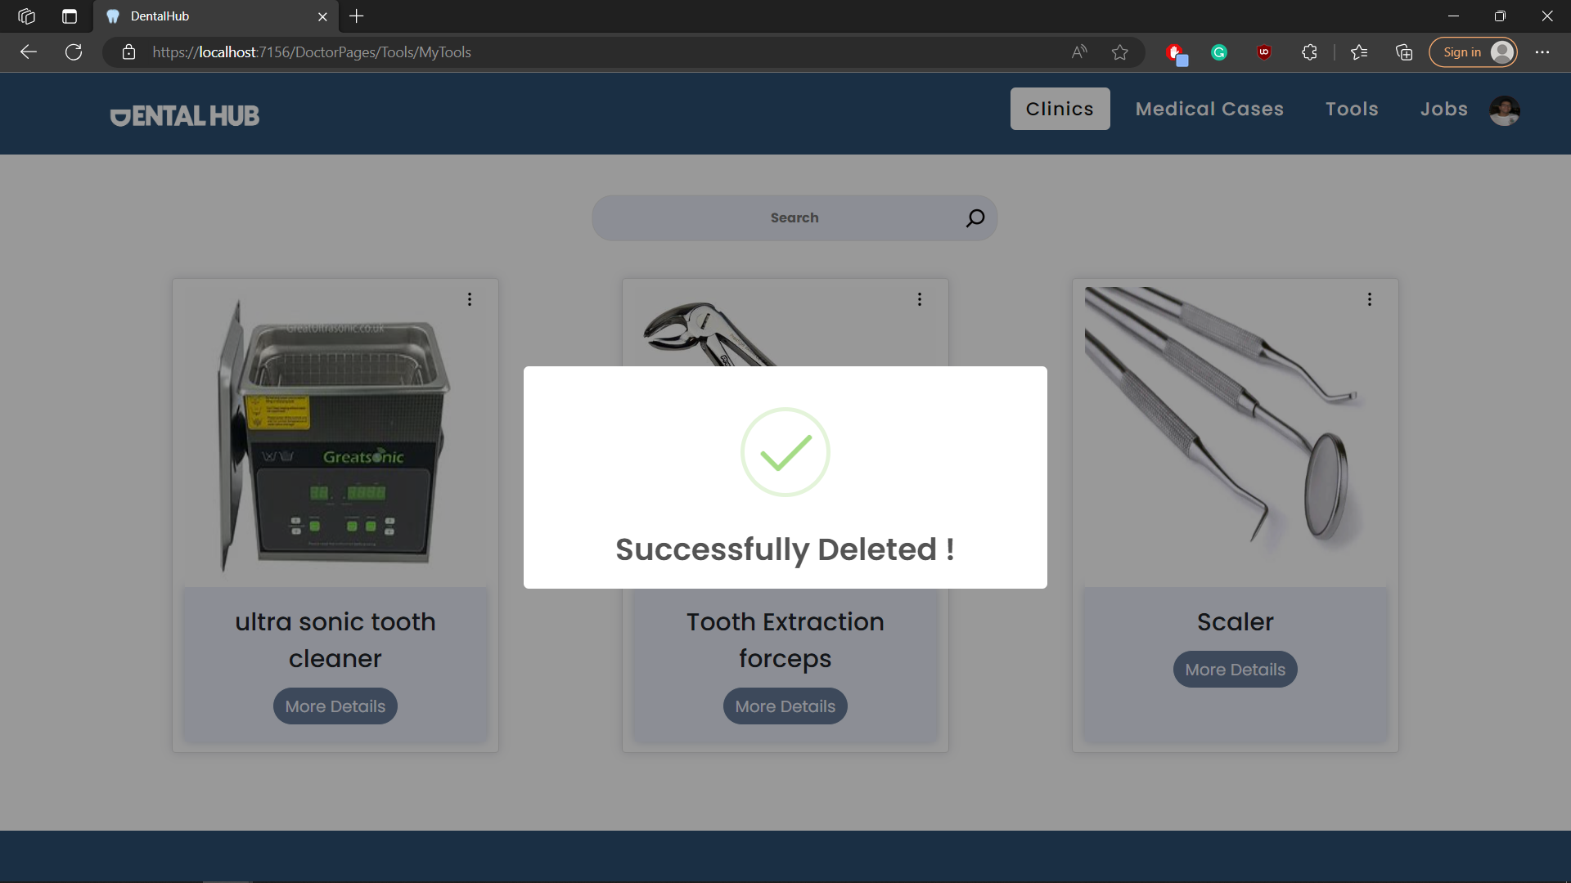

## Test case id : Tools_view

|  |  |  |  |
| --- | --- | --- | --- |
| Test Case | Test Steps | Test Data | Expected Result |
| Dentist shows tool details | 1-Go to Tools / my tools page  2-chose the tool you want and press more details |  | Shows all tool data |

